THIS IS THE ACTIVE FILE

Read and edit this in Microsoft Word
with "show hidden text= on"
(that setting is usually in "tools/options/view")

*STATA_APST470_APST670
Mariah Evans and Jonathan Kelley’s introductory notes for the applied statistics regression class APST 470/670 and for Stats Club Monday group.
UNR and International Survey Center, February 2012

Version 201202e

Section #1. PRELIMINARIES: Get Stata running on UNR Citrix
0. If you have a data stick/ thumb drive, stick it in now.

1. Log on to UNR DataWorks Citrix server from your browser. Start by Googling "unr dataworks" and choosing "DataWorks Lab":


2. Then click through to Citrix and log yourself in with your UNR ID:


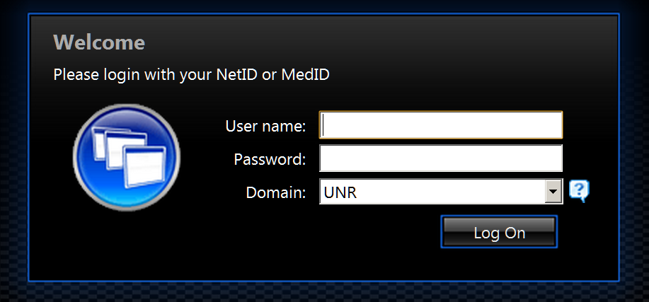

3. Find Stata and double click on it:
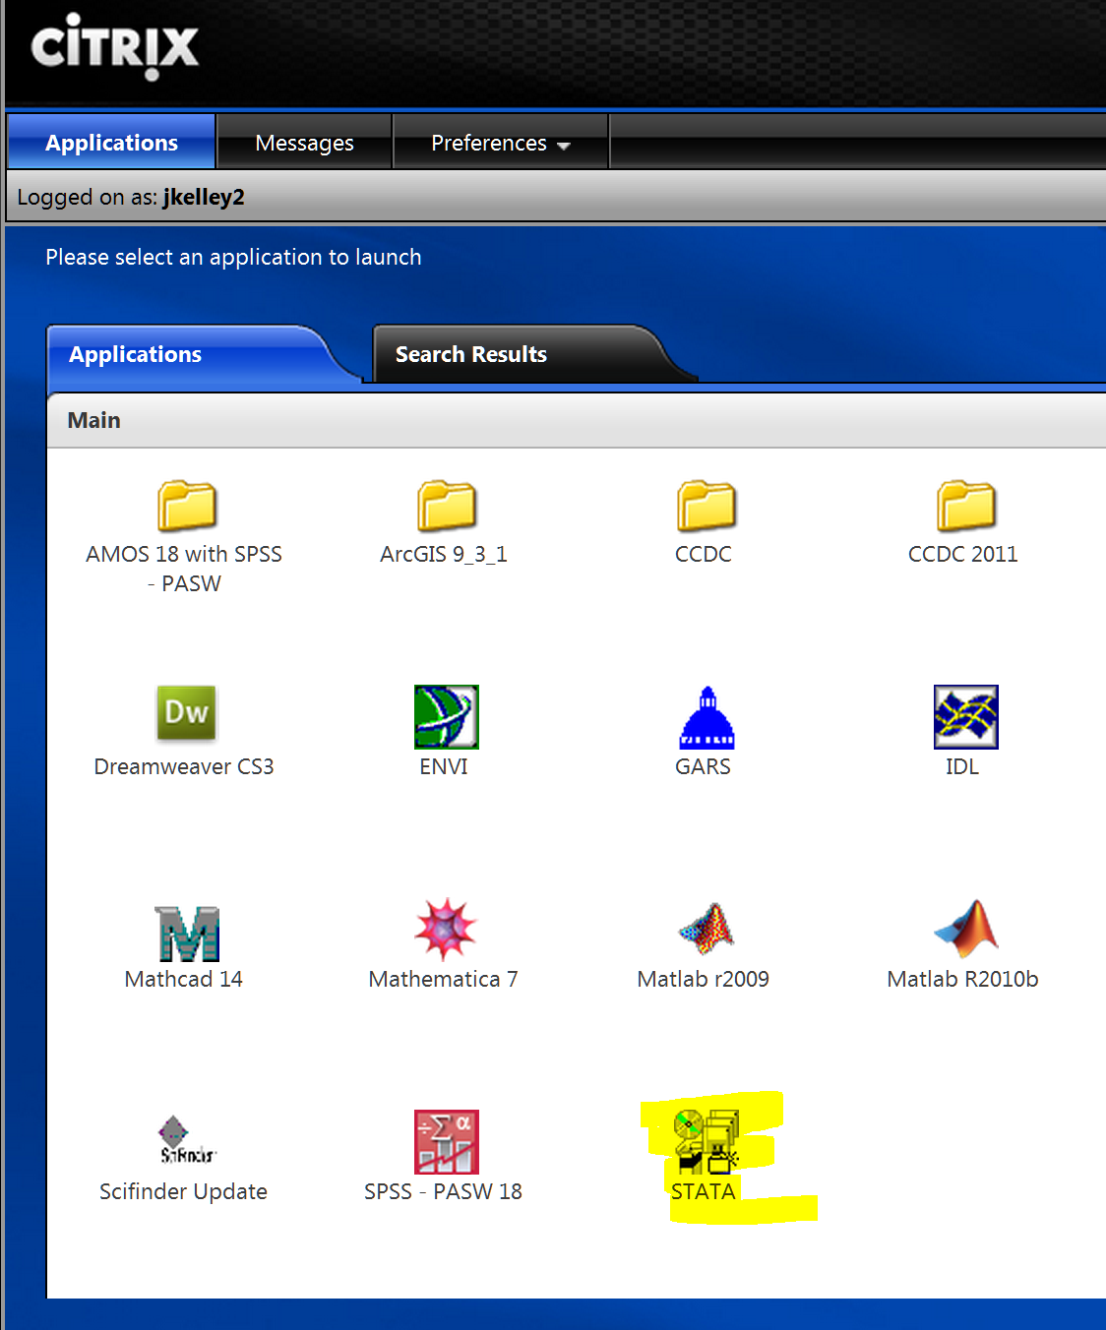

- Sometimes Citrix will launch Stata immediately. That is what you want, so wait patiently (Citrix is slow).
- Sometimes Citrix gets your browser to ask "Do you want to run this or to save it?" You want to run it
- Other times (annoyingly) it wants you to save a small shortcut file -- if so, double click on it to get Stata. (In my browser, Google Chrome, after you save, it appears in the lower left hand corner and you double click it directly from there. That works OK, but saving it to a file on your computer does not. Confusing!)
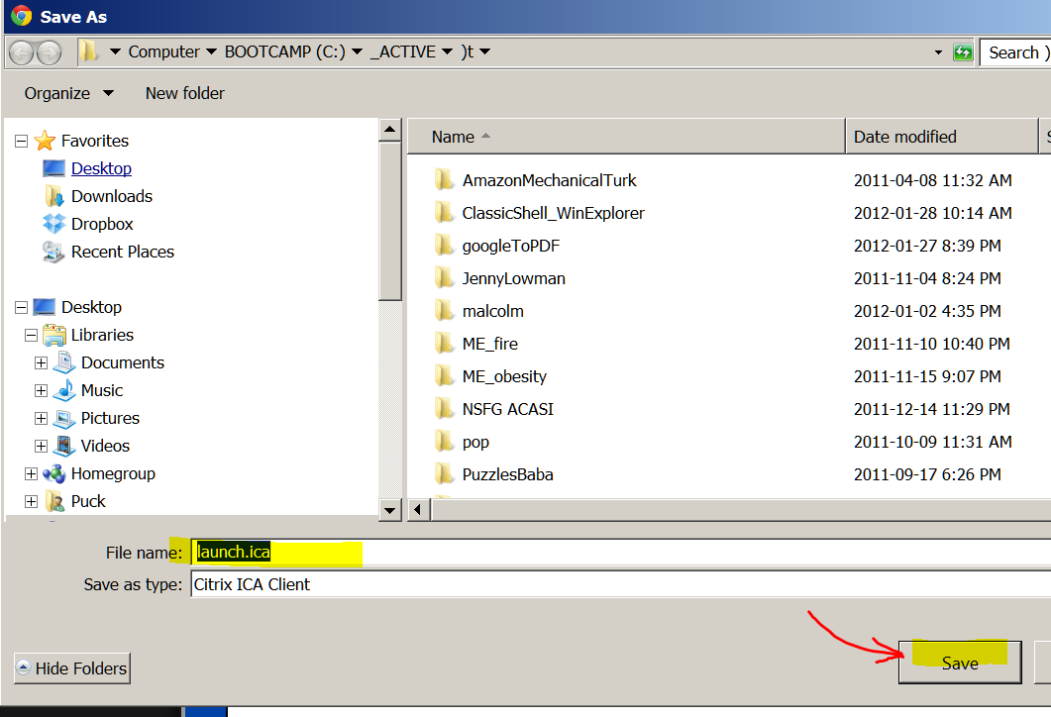

4. Stata then opens. Expand the "Results window" so you can see everything conveniently. Now you are ready to run Stata.

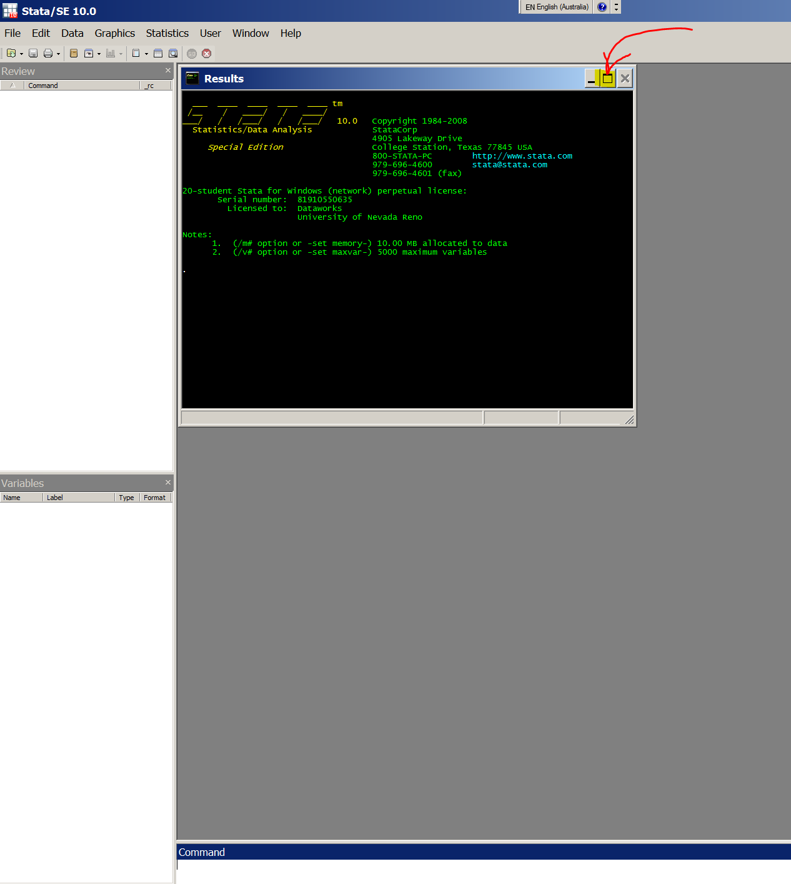

5. In Stata choose:
WINDOW/ DO FILE EDITOR / NEW DO-FILE

to open a "do file" window (so you can paste a whole batch of things in it to run at one go):

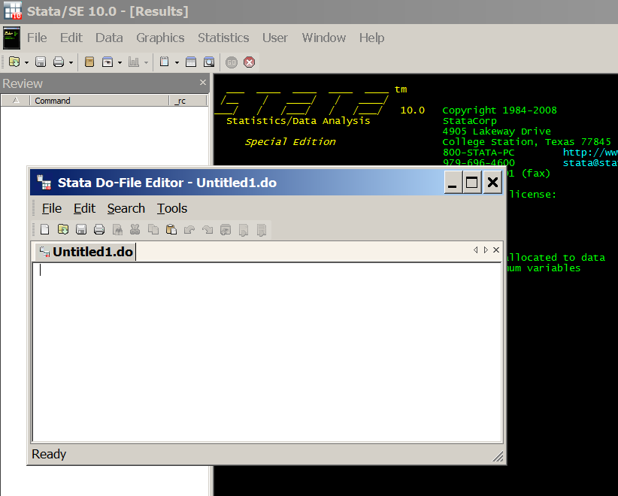

A. For the first time you run things on Citrix you have to do things this way, afterwards another way.

6. Copy-and-paste into the Stata "do file" the following (just to set up Stata conveniently):
clear
set memory 400m
set more off, permanently
set varlabelpos 12
set varabbrev off
set scrollbufsize 250000

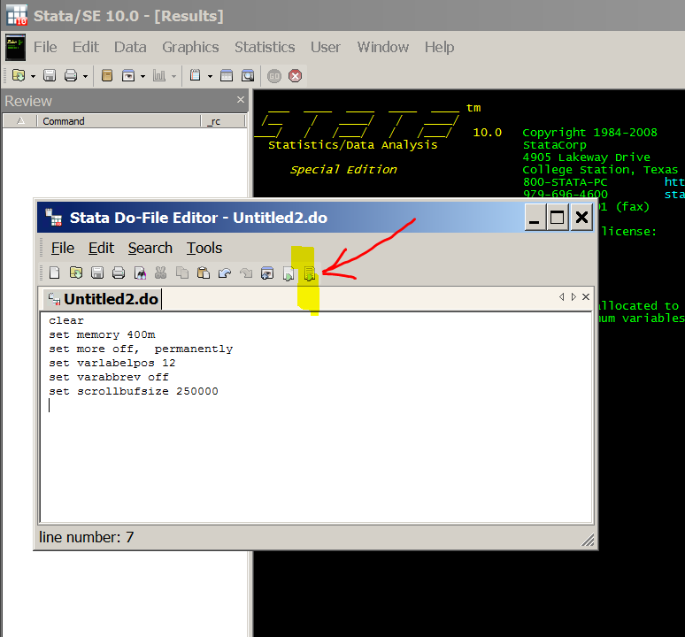

7. run (use the icon to the far right in the do file). You will see something like this: (It may be hiding behind the do-file window; if so, click on the main Stata window to get it in front of the do-file window) :
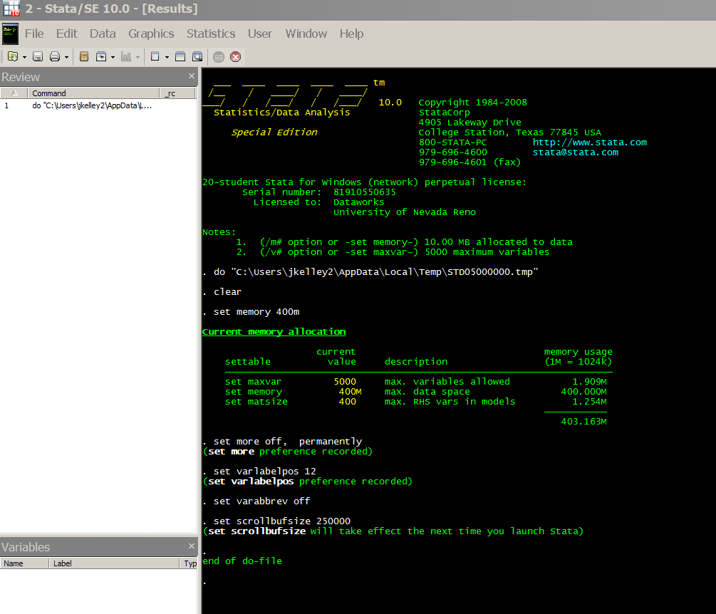

8. Now comes the hard part (but you will only have to do it the first time you run things on Citrix). You need to find the data. In Stata choose:
FILE/ OPEN
and navigate to YOUR computer (or data stick or wherever you have the data file).

If the file is on your computer (not a data stick) this will happen:
It is often drive "V" and you may have to click on three things in a row to get there (and perhaps expand the window to get enough room to see things):
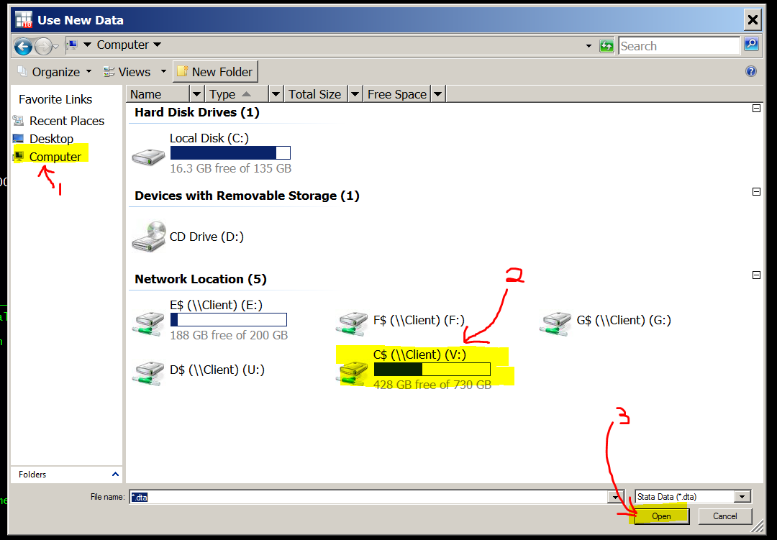

Then navigate to the data file -- it will be where you saved it on your computer. This is where it is on my machine, yours will be different. The file we are after is IsssUSA_AnalysisVars_1.dta . The ".dta" extension will probably not show up (it is there but the Citrix default is not to show it).

If you have the data file on a thumb drive, this is what will happen.
A thumb drive may be convenient for you, it may be a little harder to find.

A Citrix "got you" danger: You should plug in your thumb drive BEFORE opening Stata. If you do it afterwards, Stata may not see it (and you will get very frustrated looking for it!)

Even then, the thumb drive is hard to find in Citrix because there are lots of other obscure locations listed. Here is an example where I clicked through on the WRONG location, and was told so:
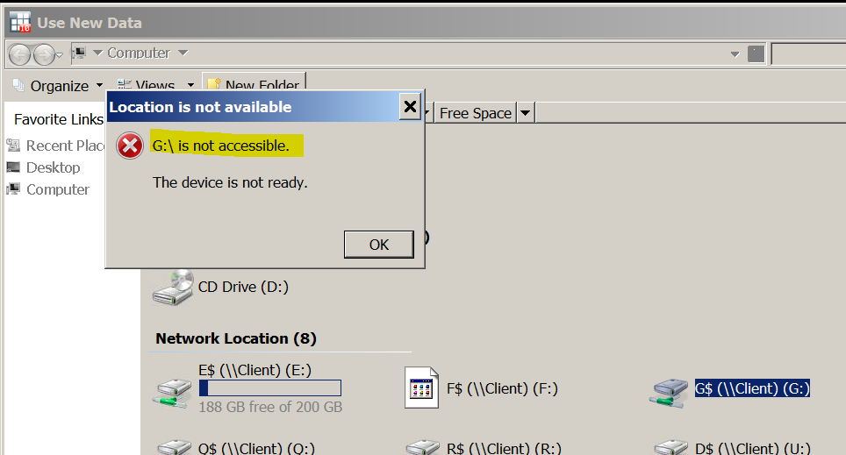

Keep looking until you find the data file. Here is my thumb drive:
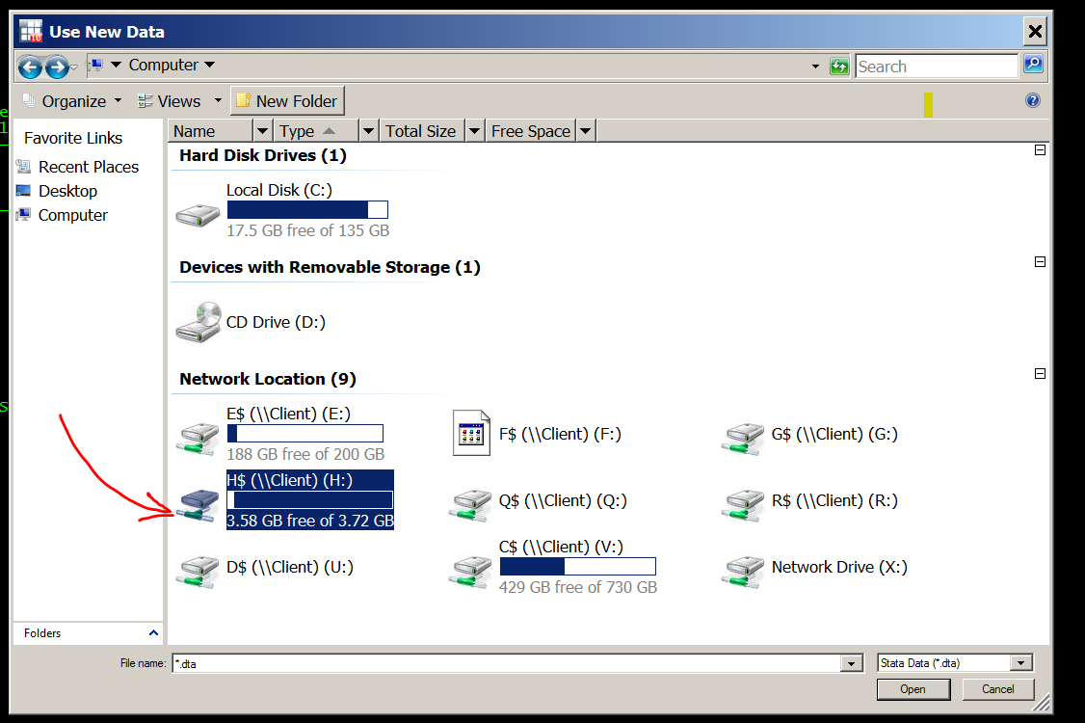

Open the file:
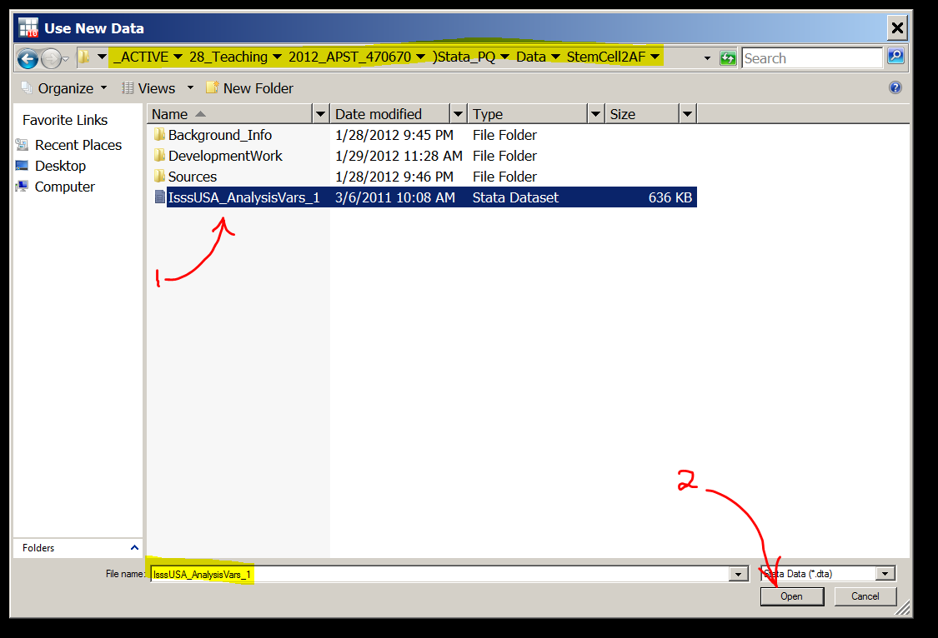

For both cases (thumb drive or file on your computer proper):

Stata will then get the data and (conveniently) show the command it used in the "Results" window. This is what things will look like:
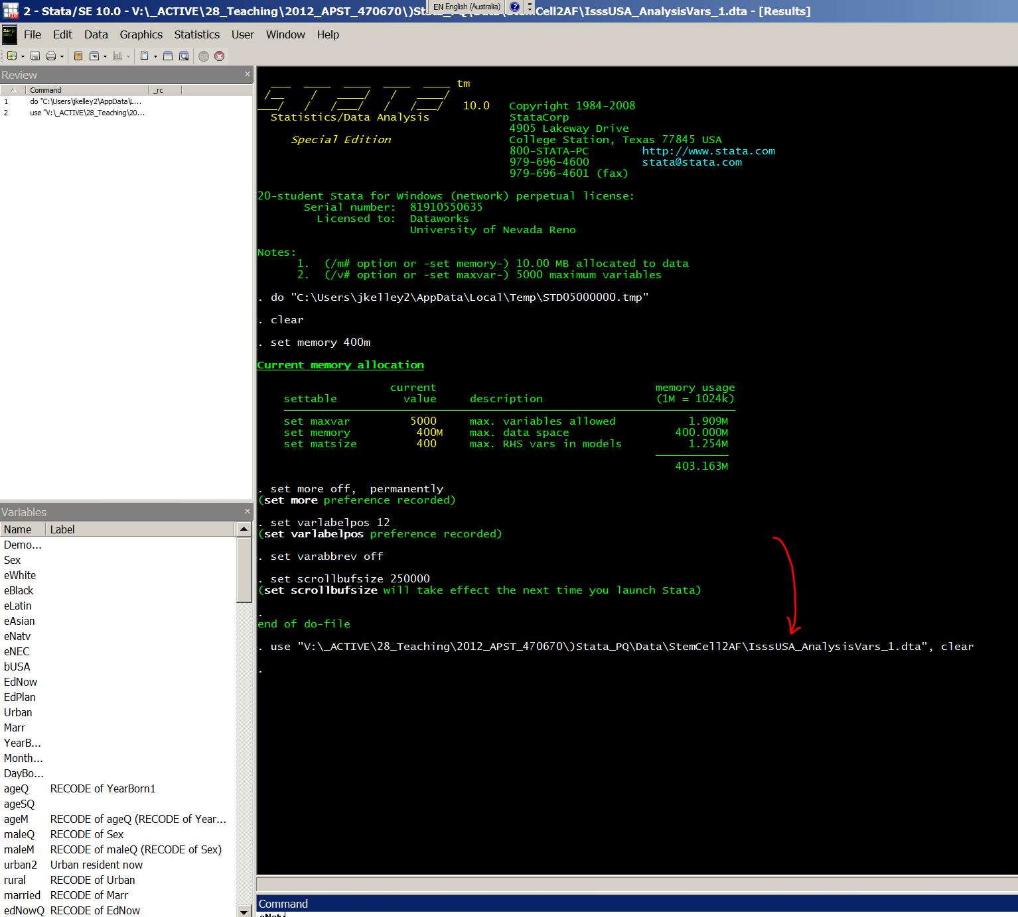

9. Copy that line (sweeping it followed by Control-C will get it). Here is the line for my computer (which has a huge file structure, so a very long path):
use "V:\_ACTIVE\28_Teaching\2012_APST_470670\)Stata_PQ\Data\StemCell2AF\IsssUSA_AnalysisVars_1.dta", clear

It may look a bit funny on the screen if there are more than 80 characters, as in my example just above. But that does not bother Stata.

For my thumb drive, it is much shorter:
use "H:\IsssUSA_AnalysisVars_1.dta", clear

Then paste it into the text just below (in Section #2 of THIS document) for future use. Do it where it says:
*Change the bit in red to reflect your file location.

B. AFTER the first time you run things on Citrix, it is much easier. Do it this way:

You will have pasted the file location on your computer into the text in Section #2 below in this file. Copy and paste all of Section #2 (in the grey box) into the Stata do file and run it:

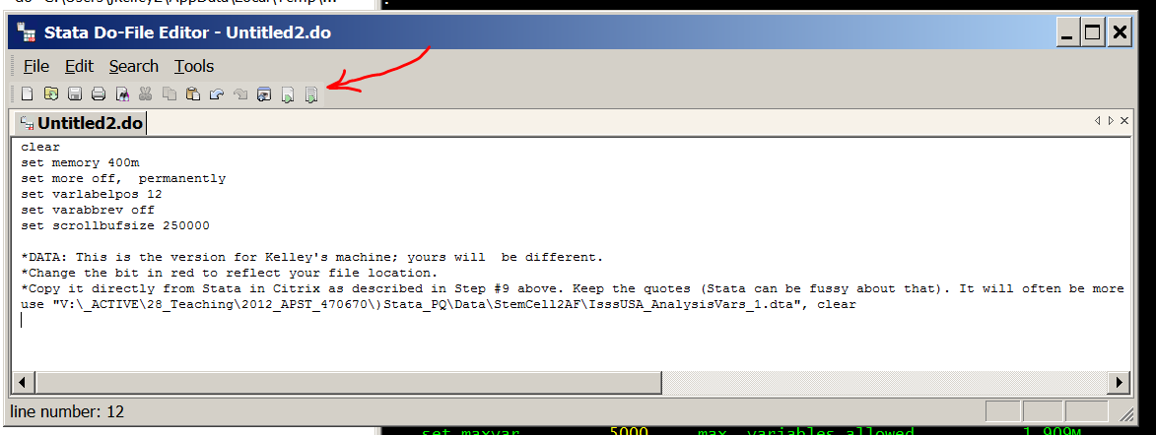

This is what the Stata "Results" screen will look like.
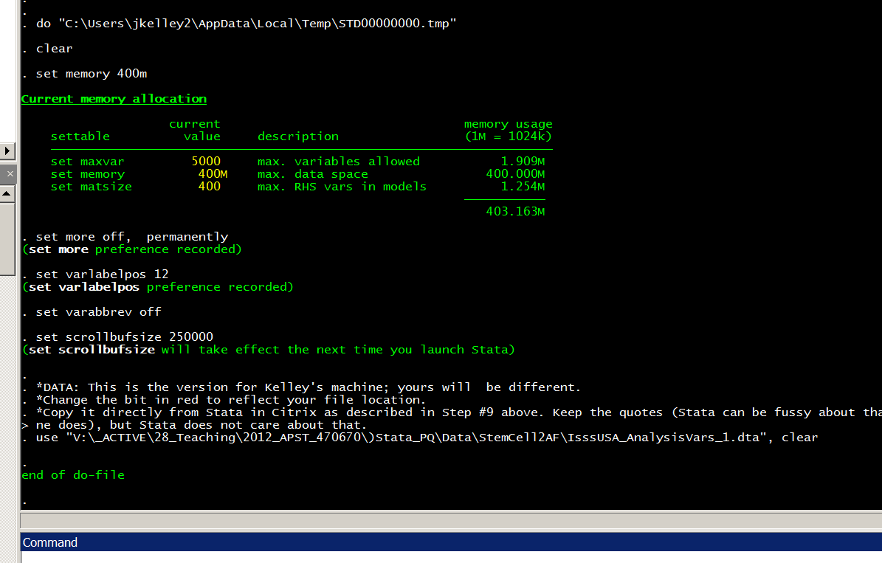

All is well; you are up and running.

*Section #2: USUALLY BEGIN HERE: Standard Stata set up
NORMAL PROCEDURE
(1) Start Stata (see the notes above in Section #1)

(2) Copy and paste all of this (Section #2 in the grey box below) in a Stata do-file. Run it. (See Section #1 above, Part B, for notes on how to do that.) This will get your data file loaded -- often the hardest part!

(3) Then run everything in Section #3 (there won't be anything there for the first week or two, but afterwards there will be). How to do that:
Open a do-file
Erase anything that is in it already
Paste all of Section #3 in the do-file.
Run it.
That gets Stata up and running, with all the basic variables defined & ready to go. You must do this once at the beginning of your session -- you can not pick and choose, but need to run everything in Sections #2 and #3.

(4) Afterwards, run anything you want from Section #4, which has the week-by-week stuff. You can pick and choose here, running only the bits you want and ignoring the rest.

Do not worry about material in hidden text (usually in a blue box like this one) as it will not be copied.

*NORMALLY BEGIN HERE & RUN EVERYTHING TO THE END OF SECTION #3
*THEN YOU CAN CONTINUE AT WEEK #2, OR #3 OR #5, ...ETC...

clear
set memory 400m
set more off, permanently
set varlabelpos 12
set varabbrev off
set scrollbufsize 250000

*DATA: This is the version for our home machine; yours will be different.
*Change the bit in red to reflect your file location. Done&&&
*Copy it directly from Stata in Citrix as described in Step #9 above. Keep the quotes (Stata can be fussy about that). It will often be more than 80 characters and look funny on the screen (as mine does), but Stata does not care about that.

*On ME's machine
*use "E:\IsssUSA_AnalysisVars_1.dta", clear

*On JK's machine
use "C:\_ACTIVE\28_Teaching\2012_APST_470670\)Stata_PQ\Data\StemCell2AF\IsssUSA_AnalysisVars_1.dta"

*Section #3: variable definitions & other preliminaries

*Occupation dummies
tab status
recode status (100=1)(10 / 90=0)(*=.), gen( prof)
label variable prof "Professional occupation"
tab prof, m
table status, c(m prof freq) m

*Week 4 work here... (we came back after first working with previously prepared variables)

*Income
*We included log income in the data file, but forgot income in dollars. So re-create it.
sum lnFamInc
tab lnFamInc
gen famInc = exp( lnFamInc)
replace famInc = round(famInc, 0.5)
label variable famInc "Family income ($1000s)"
tab famInc,m
famInc | Freq. Percent Cum.
------------+-----------------------------------
.5 | 284 12.37 12.37
5 | 44 1.92 14.29
10 | 43 1.87 16.17
15 | 57 2.48 18.65
20 | 94 4.10 22.75
25 | 76 3.31 26.06
30 | 77 3.36 29.41
35 | 95 4.14 33.55
40 | 73 3.18 36.73
45 | 83 3.62 40.35
50 | 90 3.92 44.27
55 | 52 2.27 46.54
60 | 72 3.14 49.67
65 | 62 2.70 52.37
70 | 56 2.44 54.81
75 | 71 3.09 57.91
80 | 57 2.48 60.39
90 | 59 2.57 62.96
100 | 81 3.53 66.49
125 | 73 3.18 69.67
150 | 50 2.18 71.85
200 | 20 0.87 72.72
250 | 12 0.52 73.25
450 | 14 0.61 73.86
. | 600 26.14 100.00
------------+-----------------------------------
Total | 2,295 100.00
Income always has a lot of missing data, but this is more than usual. I don't like it. But there is not much to do about it in this data set (the original data has individual income and employmet information, and something might be done there).
sum famInc
regress famInc status maleQ ageQ edNowQ edNowSq , beta

*Gender
*First, look your variable up in the codebook to see the verbatim question

Sex Are you...
Male
Female

*Get your frequency distribution using the tab command.
*Always use the "m" option to get it to show missing data, if any exist

tab1 Sex, m

tab Sex, m

Sex | Freq. Percent Cum.
------------+-----------------------------------
-1 | 147 6.41 6.41
1 | 1,048 45.66 52.07
2 | 1,100 47.93 100.00
------------+-----------------------------------
Total | 2,295 100.00

* Create a new variable called "female" from the raw variable "Sex".
* The missing value in the raw variable is "-1", so you will recode that to "." which is STATA's missing data code: cases with . on a variable will be left out of calculations using that variable.
recode Sex (2=1)(1=0)(-1 = .), gen( female)

*When you have made a new variable ALWAYS "tab" it, to check for errors.

tab female, m
*If the frequency distribution on your new variable looks ok, next cross-tabulate it with the original variable as a second error check.

tab Sex female,m
. tab female, m
RECODE of |
Sex | Freq. Percent Cum.
------------+-----------------------------------
0 | 1,048 45.66 45.66
1 | 1,100 47.93 93.59
. | 147 6.41 100.00
------------+-----------------------------------
Total | 2,295 100.00

. tab Sex female,m
| RECODE of Sex
Sex | 0 1 . | Total
-----------+---------------------------------+----------
-1 | 0 0 147 | 147
1 | 1,048 0 0 | 1,048
2 | 0 1,100 0 | 1,100
-----------+---------------------------------+----------
Total | 1,048 1,100 147 | 2,295

*Religion: Interactions [from Week 3]
gen chXfund = fundmQ * chGoNowQ

*Education: Quadratics [from week 7]
*get rid of an old version, to avoid confusion
capture drop edNowSQ
gen edNowSq = edNowQ^2

*Moral authority
*Next, we'll work on making some scales of trust in moral authorities. Prior research suggests that some people tend to turn to religious authorities, some to scientific/ medial authorities, and some prefer to judge for themselves. We are making these variables because we will later use regression to analyze their impact on attitudes towards biotechnologies using stem cells. The reason we make multiple-item scales/ indices is that, when this procedure is justified, it gives us better estimates because it reduces random measurement error, and hence brings us close to unbiased, consistent estimates.

*First check out the exact wording or measurement procedure in the codebook.
In deciding whether it is right to allow these treatments, who would you believe...
Believe!!
Believe
??
Not
Not!!

mrlEthC a. A government Ethics Committee set up to decide what is right?
...

*Use tab1 when want frequencies for several variables
*Always use the "m" option to get it to show missing data, if any exist

tab1 mrlEthC mrlMD mrlYou1st mrlPope mrlABC mrlFund mrlNIH mrlYou, m

mrlEthC | Freq. Percent Cum.
------------+-----------------------------------
-1 | 94 4.10 4.10
1 | 246 10.72 14.81
2 | 507 22.09 36.91
3 | 746 32.51 69.41
4 | 339 14.77 84.18
5 | 363 15.82 100.00
------------+-----------------------------------
Total | 2,295 100.00

*Here, strongly believing is coded 1 and strongly disbelieving is coded 5. Because it is going to be easier to talk/write about "believing increases" rather than "disbelieving decreases", we are going to recode this item to reverse the order of the scores. Moreover, readers will not have a strong intuitive grasp of the metric (1 to 5), so we will map these scores at equal intervals onto a 0 to 100 metric. Readers find 0 to 100 scoring easy to understand because it is similar to something they are very familiar with (%s).
*When recoding a variable ALWAYS, ALWAYS make it a new variable with a new name. That let's you do the proper error check. And, sooner or later even after error checking you will be part way into your analysis and you will discover that you have made a coding error. If you have written over the top of your original variable it will be a mess. If you just have to correct your new variable, it will be easy. Do yourself a favor and make a habit!
*Variable naming conventions: If you have a number of related questions, you will often find it is efficient to signal that to yourself and your co-workers with a prefix. In this case, these questions are all about moral authority, so we have used the prefix "mrl". If the original variable name is meaningful (i.e. not v003 etc), then you probably want to retain it inside the new name. Best practice is to keep the old name and add "R" at the end to signify that it is a recoded version. For example, the raw variable mrlEthC is recoded into the new variable mrlEthCR which is ready to use in your analysis. STATA allows long variable names, but try to keep them short, because if you use long ones, STATA does not display them properly in several important statistics.

recode mrlEthC (1=100)(2=75)(3=50)(4=25)(5=0)(-1 = .),gen( mrlEthCR)

*Now do the standard checks for coding errors in your new variable. Is it ok?
tab mrlEthCR, m
tab mrlEthC mrlEthCR, m

*Copy your results as tables and paste them in the blue box below. The box is blue, outlined with a dashed line, and the things inside it are in "hidden text". This is a convenient way to keep track of your foundational and intermediate results. It makes it easier to retrace your steps when you find errors and make it easy for people sharing a STATA file to see what their co-workers have done.

X

*Let's see what it would look like if you accidentally put two original codes into one new code
recode mrlEthC (1=100)(2=75)(3=75)(4=25)(5=0)(-1 = .),gen( mrlEthCW)
tab mrlEthCW, m
tab mrlEthC mrlEthCW, m

*We would hope to notice that there should be 50's in mrlEthCW but there aren't. Even if we missed that clue, how we we tell from the crosstabulation that something was wrong? Now let's wipe mrlEthCW from our memories & get back to doing things right. You won't need to see mrlEthCW again, so go up and star out those commands. Save your file with a new version key. You'll notice that the file has a rather long name. Someday you, too, will have over 200,000 files on your computer & you will need a good way to keep track of them. The "p" here is my version indicator. Make the next version which you are saving now "r".

*----Now do the rest. As in building a house, the preparation stage takes a while, can be tedious, and is absolutely essential. Great care and precision are required here!

recode mrlMD mrlYou1st mrlPope mrlABC mrlFund mrlNIH mrlYou (1=100)(2=75)(3=50)(4=25)(5=0)(-1 = .),gen( mrlMDR mrlYou1stR mrlPopeR mrlABCR mrlFundR mrlNIHR mrlYouR)
tab1 mrlMDR mrlYou1stR mrlPopeR mrlABCR mrlFundR mrlNIHR mrlYouR, m
tab mrlMD mrlMDR ,m
*All ok with mrlMDR?
*Now you do the checks on mrlYou1stR. Because this is an example and I already checked you do not need to do the rest now. In your own data you need to do this with every variable you are going to use.

*Means, frequencies: understanding points out of 100
* First, look at the question wording or measurement details for you item and copy thm in here. I've done this one for you, but you SOP should always be to keep your measurement details inside the data preparation for that variable.
In deciding whether it is right to allow these treatments, who would you believe...
100 Believe!!
75 Believe
50 ??
25 Not
0 Not!!

mrlEthC a. A government Ethics Committee set up to decide what is right?

tab mrlMDR ,m
sum mrlMDR
RECODE of |
mrlMD | Freq. Percent Cum.
------------+-----------------------------------
0 | 155 6.75 6.75
25 | 151 6.58 13.33
50 | 687 29.93 43.27
75 | 797 34.73 78.00
100 | 411 17.91 95.90
. | 94 4.10 100.00
------------+-----------------------------------
Total | 2,295 100.00

.
. sum mrlMDR
Variable | Obs Mean Std. Dev. Min Max
-------------+--------------------------------------------------------
mrlMDR | 2201 63.15311 27.19222 0 100

* --- If you are going to show a table or graph of the frequency distribution, you usually present the %s with the missing data taken out. To get this table omit the usual "m" at the end of the "tab" command.
tab mrlMDR
* Paste your output here. Make your own blue box.

*--- Compare: which has more authority, in people's opinion?
sum mrlMDR mrlNIHR

*--- All in all, who has most authority and who least?
sum mrlEthCR mrlMDR mrlYou1stR mrlPopeR mrlABCR mrlFundR mrlNIHR mrlYouR

*Scale for religious authority
*For a scale to be justified: (1) The items in it must have "face validity" -- there must be good reason to think that they all measure whatever the scale is supposed to represent; (2) the items must have high correlations among themselves ("inter-item correlations"); (3) the items in the scale must have similar correlations with important variables outside the scale ("Correlations with criterion variables").

*Are they all correlated?
corr mrlPopeQ mrlABCQ mrlFundQ

*Do they have similar correlations with criterion variables?
corr mrlPopeR mrlABCR mrlFundR chGoNowQ ageQ polDem9
corr mrlPopeR mrlABCR mrlFundR chGoNowQ ageQ polDem9
(obs=1989)

| mrlPopeR mrlABCR mrlFundR chGoNowQ ageQ polDem9
-------------+------------------------------------------------------
mrlPopeR | 1.0000
mrlABCR | 0.8187 1.0000
mrlFundR | 0.7693 0.8825 1.0000

chGoNowQ | 0.1456 0.1449 0.1957 1.0000
ageQ | -0.1065 -0.0782 -0.1099 0.1360 1.0000
polDem9 | -0.1250 -0.1167 -0.1600 -0.1890 -0.1031 1.0000
*The important thing about the correlations with the criterion variables is that they should be similar for all the scale items. For example, all 3 candidate items for this scale have fairly small positive correlations with churchgoing (purple bar). The point is not whether these correlations are large or small, but that they are similar. How about the correlations with another criterion variable, age? Are the correlations of the candidate items with age similar? How about PolDem9?

*To scale well, variables need to have similar standard deviations. If the standard deviations are similar in the variables as we have created them, then we can use them in scale construction as they are. If not, then we standardize before making the scale.
*Similar standard deviations?
sum mrlPopeR mrlABCR mrlFundR
Variable | Obs Mean Std. Dev. Min Max
-------------+--------------------------------------------------------
mrlPopeR | 2196 31.73953 30.76663 0 100
mrlABCR | 2194 33.80811 29.68837 0 100
mrlFundR | 2180 35.12615 30.87444 0 100
* Standard deviations here are similar, but if yours are not, standardize the variables, then look at the correlations and factor analyses. To standardize your variables, remember APST 270 and z-score them: subtract the mean and then divide by the standard deviation.

*Make a scale averaging the 3 items. Unweighted (as all have similar std devs)
*Do this using a new command "egen"
egen mrlRel9 = rowmean( mrlPopeR mrlABCR mrlFundR )
tab mrlRel9
corr mrlRel9 mrlPopeR mrlABCR mrlFundR
mrlRel9 | Freq. Percent Cum.
------------+-----------------------------------
0 | 652 29.61 29.61
8.333333 | 25 1.14 30.74
16.66667 | 84 3.81 34.56
25 | 343 15.58 50.14
33.33333 | 94 4.27 54.41
37.5 | 3 0.14 54.54
41.66667 | 90 4.09 58.63
50 | 501 22.75 81.38
58.33333 | 74 3.36 84.74
62.5 | 2 0.09 84.83
66.66666 | 81 3.68 88.51
75 | 117 5.31 93.82
83.33334 | 33 1.50 95.32
91.66666 | 13 0.59 95.91
100 | 90 4.09 100.00
------------+-----------------------------------
Total | 2,202 100.00

.
. corr mrlRel9 mrlPopeR mrlABCR mrlFundR
(obs=2167)
| mrlRel9 mrlPopeR mrlABCR mrlFundR
-------------+------------------------------------
mrlRel9 | 1.0000
mrlPopeR | 0.9195 1.0000
mrlABCR | 0.9575 0.8192 1.0000
mrlFundR | 0.9414 0.7699 0.8825 1.0000

*An important indicator of the quality of a scale is its "alpha reliability" (beware -- this is completely different from the alpha in hypothesis testing). This is also called the "Scale reliability coefficient". It ranges from 0 to 1. Over 0.7 is acceptable in most fields; over 0.8 is good; over 0.9 is excellent.

*Reliability

alpha mrlPopeR mrlABCR mrlFundR, std
Test scale = mean(standardized items)

Average interitem correlation: 0.8234
Number of items in the scale: 3
Scale reliability coefficient: 0.9333

*The average interitem correlation is the mean correlation between the items in your proposed scale. These should be high, especially if the scale has few items, as here.
* When you are giving a presentation you should always report the scale alpha and the mean inter-item correlation. For a report or article, you should always present them AND the detailed inter-item correlations and the correlations with criterion variable (if you want to keep the article or report short, you put the correlations in an appendix).

*Factor analysis
*If all is looking well thus far, you are ready to assess systematically the quality of your potential scale.

*Preliminaries
*correlations
corr mrlEthCR mrlMDR mrlYou1stR mrlPopeR mrlABCR mrlFundR mrlNIHR mrlYouR

*This was the order in which we got them from the dataset, but notice that they will be much easier to read if we rearrange them so that the candidate items for each of the three scale are groups together.

*Re-arrange, so easier to read
corr mrlPopeR mrlABCR mrlFundR mrlEthCR mrlMDR mrlNIHR mrlYou1stR mrlYouR
| mrlPopeR mrlABCR mrlFundR mrlEthCR mrlMDR mrlNIHR mrlYo~tR mrlYouR
-------------+------------------------------------------------------------------------
mrlPopeR | 1.0000
mrlABCR | 0.8192 1.0000
mrlFundR | 0.7679 0.8836 1.0000

mrlEthCR | 0.2822 0.3203 0.2706 1.0000
mrlMDR | 0.1384 0.1884 0.1225 0.5476 1.0000
mrlNIHR | 0.1220 0.1851 0.1466 0.5239 0.6620 1.0000

mrlYou1stR | 0.1491 0.1735 0.1773 0.2405 0.3940 0.3361 1.0000
mrlYouR | 0.0844 0.1040 0.1278 0.1941 0.3507 0.3517 0.7221 1.0000

*Factor analysis proper: One factor, the simplest case
*We are looking for Factor1 having an "eigenvalue" over 1, and nothing else coming close.
factor mrlPopeR mrlABCR mrlFundR

Factor analysis/correlation Number of obs = 2167
Method: principal factors Retained factors = 1
Rotation: (unrotated) Number of params = 3

--------------------------------------------------------------------------
Factor | Eigenvalue Difference Proportion Cumulative
-------------+------------------------------------------------------------
Factor1 | 2.41679 2.45500 1.0539 1.0539
Factor2 | -0.03821 0.04709 -0.0167 1.0372
Factor3 | -0.08530 . -0.0372 1.0000
--------------------------------------------------------------------------
LR test: independent vs. saturated: chi2(3) = 5740.60 Prob>chi2 = 0.0000

Factor loadings (pattern matrix) and unique variances

---------------------------------------
Variable | Factor1 | Uniqueness
-------------+----------+--------------
mrlPopeR | 0.8451 | 0.2859
mrlABCR | 0.9385 | 0.1192
mrlFundR | 0.9066 | 0.1782
---------------------------------------
*Note that all factor loadings are high

*Factor analysis: scale plus an item that does not belong

*---Preliminaries: the new item looks bad
corr mrlPopeR mrlABCR mrlFundR ageQ
| mrlPopeR mrlABCR mrlFundR ageQ
-------------+------------------------------------
mrlPopeR | 1.0000
mrlABCR | 0.8208 1.0000
mrlFundR | 0.7742 0.8842 1.0000
ageQ | -0.1132 -0.0899 -0.1204 1.0000

*---Factor analysis shows its bad also
factor mrlPopeR mrlABCR mrlFundR ageQ
Factor analysis/correlation Number of obs = 2078
Method: principal factors Retained factors = 2
Rotation: (unrotated) Number of params = 6

--------------------------------------------------------------------------
Factor | Eigenvalue Difference Proportion Cumulative
-------------+------------------------------------------------------------
Factor1 | 2.43968 2.42712 1.0502 1.0502
Factor2 | 0.01256 0.05063 0.0054 1.0556
Factor3 | -0.03806 0.05311 -0.0164 1.0392
Factor4 | -0.09117 . -0.0392 1.0000
--------------------------------------------------------------------------
LR test: independent vs. saturated: chi2(6) = 5593.63 Prob>chi2 = 0.0000

Factor loadings (pattern matrix) and unique variances

-------------------------------------------------
Variable | Factor1 Factor2 | Uniqueness
-------------+--------------------+--------------
mrlPopeR | 0.8479 -0.0110 | 0.2810
mrlABCR | 0.9378 0.0301 | 0.1197
mrlFundR | 0.9094 -0.0067 | 0.1729
ageQ | -0.1197 0.1072 | 0.9742
-------------------------------------------------
*The factor loading for the item that does not belong is very small.

*Factor analysis revealing several concepts
*The process is very similar to when we are testing for one factor (factors are also sometimes called "dimensions", "Concepts" or "true variables").
*We have already seen the correlations (above)

*----- Also need to look at correlations with criterion variables
corr mrlPopeR mrlABCR mrlFundR mrlEthCR mrlMDR mrlNIHR mrlYou1stR mrlYouR maleQ ageQ edNowQ polDem9 ChGoNow
| mrlPopeR mrlABCR mrlFundR mrlEthCR mrlMDR mrlNIHR mrlYo~tR mrlYouR
-------------+------------------------------------------------------------------------
mrlPopeR | 1.0000
mrlABCR | 0.8209 1.0000
mrlFundR | 0.7733 0.8857 1.0000
mrlEthCR | 0.2671 0.3023 0.2503 1.0000
mrlMDR | 0.1220 0.1641 0.0963 0.5284 1.0000
mrlNIHR | 0.1023 0.1621 0.1203 0.5050 0.6444 1.0000
mrlYou1stR | 0.1358 0.1637 0.1733 0.2222 0.3765 0.3204 1.0000
mrlYouR | 0.0721 0.0922 0.1156 0.1717 0.3313 0.3268 0.7136 1.0000

maleQ | 0.0691 0.0572 0.0575 -0.0177 0.0410 -0.0163 -0.0469 -0.0337
ageQ | -0.1120 -0.0906 -0.1162 -0.1234 -0.0238 -0.0558 -0.0778 -0.0723
edNowQ | -0.0381 -0.0318 -0.0585 -0.0070 0.0036 0.0166 0.0336 0.0521
polDem9 | -0.1222 -0.1137 -0.1549 0.2219 0.1929 0.1907 0.0443 0.0480
chGoNowQ | 0.1451 0.1406 0.1927 -0.0703 -0.1712 -0.1554 -0.1082 -0.1051
cathQ | 0.3228 0.1953 0.1486 0.0314 0.0069 0.0265 -0.0200 -0.0126
*Not perfect, but the balance of the evidence is that the correlations with criterion variable support the hypothesis that the three posited scales exist.

*---factor analysis
factor mrlPopeR mrlABCR mrlFundR mrlEthCR mrlMDR mrlNIHR mrlYou1stR mrlYouR
actor analysis/correlation Number of obs = 2135
Method: principal factors Retained factors = 3
Rotation: (unrotated) Number of params = 21

--------------------------------------------------------------------------
Factor | Eigenvalue Difference Proportion Cumulative
-------------+------------------------------------------------------------
Factor1 | 3.01094 1.31448 0.6255 0.6255
Factor2 | 1.69647 1.03499 0.3524 0.9779
Factor3 | 0.66148 0.68745 0.1374 1.1153
Factor4 | -0.02597 0.05307 -0.0054 1.1099
Factor5 | -0.07904 0.02888 -0.0164 1.0935
Factor6 | -0.10792 0.03539 -0.0224 1.0711
Factor7 | -0.14331 0.05541 -0.0298 1.0413
Factor8 | -0.19872 . -0.0413 1.0000
--------------------------------------------------------------------------
LR test: independent vs. saturated: chi2(28) = 1.0e+04 Prob>chi2 = 0.0000

Factor loadings (pattern matrix) and unique variances

-----------------------------------------------------------
Variable | Factor1 Factor2 Factor3 | Uniqueness
-------------+------------------------------+--------------
mrlPopeR | 0.7065 -0.4632 0.0260 | 0.2856
mrlABCR | 0.8055 -0.4882 0.0061 | 0.1128
mrlFundR | 0.7599 -0.4909 0.0819 | 0.1749
mrlEthCR | 0.5466 0.2408 -0.3334 | 0.5321
mrlMDR | 0.5360 0.5036 -0.2854 | 0.3776
mrlNIHR | 0.5188 0.4759 -0.2917 | 0.4192
mrlYou1stR | 0.4918 0.4663 0.4263 | 0.3590
mrlYouR | 0.4339 0.4970 0.4412 | 0.3701
-----------------------------------------------------------

*---That was ugly. We need to rotate. Rotation is the extra step we need to find several factors.
rotate
Factor analysis/correlation Number of obs = 2135
Method: principal factors Retained factors = 3
Rotation: orthogonal varimax (Kaiser off) Number of params = 21

--------------------------------------------------------------------------
Factor | Variance Difference Proportion Cumulative
-------------+------------------------------------------------------------
Factor1 | 2.48672 0.92418 0.5166 0.5166
Factor2 | 1.56253 0.24289 0.3246 0.8412
Factor3 | 1.31964 . 0.2741 1.1153
--------------------------------------------------------------------------
LR test: independent vs. saturated: chi2(28) = 1.0e+04 Prob>chi2 = 0.0000

Rotated factor loadings (pattern matrix) and unique variances

-----------------------------------------------------------
Variable | Factor1 Factor2 Factor3 | Uniqueness
-------------+------------------------------+--------------
mrlPopeR | 0.8408 0.0769 0.0387 | 0.2856
mrlABCR | 0.9323 0.1255 0.0484 | 0.1128
mrlFundR | 0.9029 0.0508 0.0857 | 0.1749
mrlEthCR | 0.2545 0.6279 0.0944 | 0.5321
mrlMDR | 0.0844 0.7366 0.2696 | 0.3776
mrlNIHR | 0.0880 0.7169 0.2431 | 0.4192
mrlYou1stR | 0.1145 0.2198 0.7613 | 0.3590
mrlYouR | 0.0510 0.1981 0.7669 | 0.3701
-----------------------------------------------------------

*Looking good! 3 eignvalues >1 indicates 3 factors, as we expect. Loadings for the variables that are supposed to measure each factor/ underlying variable have high loadings on that factor and low loadings elsewhere.

*----- Make scales for the other two concepts

egen mrlMed9 = rowmean( mrlEthCR mrlMDR mrlNIHR)
tab mrlMed9, m
corr mrlMed9 mrlEthCR mrlMDR mrlNIHR

egen mrlYou9 = rowmean( mrlYou1stR mrlYouR )
tab mrlYou9
corr mrlYou9 mrlYou1stR mrlYouR

*------ Correlations with other variables: a 2nd and better look
corr mrlRel9 mrlMed9 mrlYou9 maleQ ageQ edNowQ polDem9 chGoNowQ, m

Variable | Mean Std. Dev. Min Max
-------------+----------------------------------------------------
mrlRel9 | 33.61376 28.66974 0 100
mrlMed9 | 58.86834 23.71164 0 100
mrlYou9 | 71.03819 23.65904 0 100
maleQ | .4868735 .499947 0 1
ageQ | 46.37375 15.98017 17 87
edNowQ | 14.08329 2.256712 10 22
polDem9 | .5340119 .3304676 0 1
ChGoNow | 3.55895 2.807283 -1 9

| mrlRel9 mrlMed9 mrlYou9
-------------+-----------------------------
mrlRel9 | 1.0000
mrlMed9 | 0.2260 1.0000
mrlYou9 | 0.1449 0.3681 1.0000

maleQ | 0.0678 0.0045 -0.0428
ageQ | -0.1108 -0.0873 -0.0831
edNowQ | -0.0530 0.0046 0.0465
polDem9 | -0.1419 0.2401 0.0491
ChGoNow | 0.1984 -0.1576 -0.1058

*Another factor analysis: Your data

*[ do two examples with class data]

*If we have time, we'll do the theory today, but we need time to work on your projects, so we may turn to your projects at this point and do the theory later.

*Factor analysis: theory

*Random noise
gen e1 = invnorm(uniform())
gen e2 = invnorm(uniform())
gen e3 = invnorm(uniform())
gen e4 = invnorm(uniform())
corr e1 e2 e3 e4, m
(obs=2295)

Variable | Mean Std. Dev. Min Max
-------------+----------------------------------------------------
e1 | -.0211384 1.027497 -3.562193 2.971157
e2 | .0247844 .9880224 -3.723434 3.47072
e3 | -.0147948 .9930991 -3.19455 3.648272
e4 | -.0048265 .9851684 -3.365304 3.747546

| e1 e2 e3 e4
-------------+------------------------------------
e1 | 1.0000
e2 | -0.0032 1.0000
e3 | 0.0029 -0.0069 1.0000
e4 | 0.0145 -0.0207 0.0035 1.0000

*Item = true score plus random noise

Variable | Obs Mean Std. Dev. Min Max
-------------+--------------------------------------------------------
polDem9 | 2295 .5320283 .3210737 0 1

gen polQ1 = polDem9 + .30*e1
gen polQ2 = polDem9 + .35*e2
gen polQ3 = polDem9 + .25*e3
gen polQ4 = polDem9 + .30*e4

*Shows our "usual" pattern
corr polQ1 polQ2 polQ3 polQ4 cThrp9 mrlRel9 mrlMed9 mrlYou9 edNowQ maleQ ageQ
(obs=2094)

| polQ1 polQ2 polQ3 polQ4
-------------+--------------------------------------
polQ1 | 1.0000
polQ2 | 0.5171 1.0000
polQ3 | 0.5928 0.5545 1.0000
polQ4 | 0.5514 0.5011 0.5883 1.0000

cThrp9 | 0.2120 0.2035 0.2289 0.2194
mrlRel9 | -0.1269 -0.0991 -0.1175 -0.1342
mrlMed9 | 0.1818 0.1644 0.1976 0.1794
mrlYou9 | 0.0439 0.0444 0.0327 -0.0028
edNowQ | -0.0201 -0.0201 -0.0043 -0.0462
maleQ | -0.0124 -0.0380 -0.0764 -0.0486
ageQ | -0.0688 -0.0808 -0.0953 -0.0727

*Factor analysis

factor polQ1 polQ2 polQ3 polQ4
(obs=2295)

Factor analysis/correlation Number of obs = 2295
Method: principal factors Retained factors = 1
Rotation: (unrotated) Number of params = 4

--------------------------------------------------------------------------
Factor | Eigenvalue Difference Proportion Cumulative
-------------+------------------------------------------------------------
Factor1 | 2.04050 2.13246 1.2071 1.2071
Factor2 | -0.09196 0.02692 -0.0544 1.1527
Factor3 | -0.11889 0.02029 -0.0703 1.0823
Factor4 | -0.13917 . -0.0823 1.0000
--------------------------------------------------------------------------
LR test: independent vs. saturated: chi2(6) = 3155.56 Prob>chi2 = 0.0000

Factor loadings (pattern matrix) and unique variances

---------------------------------------
Variable | Factor1 | Uniqueness
-------------+----------+--------------
polQ1 | 0.7208 | 0.4805
polQ2 | 0.6621 | 0.5616
polQ3 | 0.7606 | 0.4215
polQ4 | 0.7100 | 0.4959
---------------------------------------

*For program Eval4: Subroutine fix_vars
*Eval4 is for getting predicted values in complex models.
*You always need a version of subroutine fix_vars to keep Eval4 happy, but it can be empty (almmost).
*If you have interactions, quadratics, etc put them in fix_vars.
*Extra things in fix_vars are harmless. Nor does it matter if you are not actually using interactions and quadratics so long as fix_vars exists.
*When you do make interactions, quadratics, etc, just add them to fix_vars and re-run it -- it will overwrite older versions automatically.

capture program drop fix_vars /*Drop previous version, so can replace */
program define fix_vars

/* compute interactions & quadratics: "quietly replace" */
quietly display " "
quietly replace edNowSq = edNowQ^2

/*interactions, as previously defined but here with "quietly replace" not "gen" */
quietly replace chXfund = fundmQ * chGoNowQ

end

*Section #4: ALWAYS RUN UP TO HERE:
*Analysis (week-by-week material)

*Week 2 material

*Regression with a single dichotomous variable
tab1 maleQ cIPS9
-> tabulation of maleQ

RECODE of |
Sex | Freq. Percent Cum.
------------+-----------------------------------
0 | 1,100 51.21 51.21
1 | 1,048 48.79 100.00
------------+-----------------------------------
Total | 2,148 100.00

-> tabulation of cIPS9

cIPS9 | Freq. Percent Cum.
------------+-----------------------------------
0 | 147 6.59 6.59
8.333333 | 7 0.31 6.90
16.66667 | 12 0.54 7.44
25 | 79 3.54 10.98
33.33333 | 50 2.24 13.22
41.66667 | 67 3.00 16.22
50 | 378 16.94 33.15
58.33333 | 135 6.05 39.20
62.5 | 1 0.04 39.25
66.66666 | 215 9.63 48.88
75 | 376 16.85 65.73
83.33334 | 148 6.63 72.36
87.5 | 2 0.09 72.45
91.66666 | 155 6.94 79.39
100 | 460 20.61 100.00
------------+-----------------------------------
Total | 2,232 100.00

table maleQ , c( m cIPS9 freq)
------------------------------------
RECODE of |
Sex | mean(cIPS9) Freq.
----------+-------------------------
0 | 65.01744 1,100
1 | 69.38077 1,048
------------------------------------
disp 69.38 - 65.017
4.363

regress cIPS9 maleQ
Source | SS df MS Number of obs = 2146
-------------+------------------------------ F( 1, 2144) = 13.57
Model | 10208.2396 1 10208.2396 Prob > F = 0.0002
Residual | 1612475.28 2144 752.08735 R-squared = 0.0063
-------------+------------------------------ Adj R-squared = 0.0058
Total | 1622683.52 2145 756.495813 Root MSE = 27.424

------------------------------------------------------------------------------
cIPS9 | Coef. Std. Err. t P>|t| [95% Conf. Interval]
-------------+----------------------------------------------------------------
maleQ | 4.36333 1.184341 3.68 0.000 2.040753 6.685908
_cons | 65.01744 .8272472 78.59 0.000 63.39515 66.63973
------------------------------------------------------------------------------

ttest cIPS9, by(maleQ)
Two-sample t test with equal variances
------------------------------------------------------------------------------
Group | Obs Mean Std. Err. Std. Dev. [95% Conf. Interval]
---------+--------------------------------------------------------------------
0 | 1099 65.01744 .8484643 28.12758 63.35265 66.68223
1 | 1047 69.38077 .8241062 26.66592 67.76368 70.99786
---------+--------------------------------------------------------------------
combined | 2146 67.14624 .5937292 27.50447 65.9819 68.31059
---------+--------------------------------------------------------------------
diff | -4.36333 1.184341 -6.685908 -2.040753
------------------------------------------------------------------------------
diff = mean(0) - mean(1) t = -3.6842
Ho: diff = 0 degrees of freedom = 2144

Ha: diff < 0 Ha: diff != 0 Ha: diff > 0
Pr(T < t) = 0.0001 Pr(|T| > |t|) = 0.0002 Pr(T > t) = 0.9999

*Regression with a single continuous variable

table edNowQ, c(m cIPS9 freq)
------------------------------------
RECODE of |
EdNow | mean(cIPS9) Freq.
----------+-------------------------
10 | 57.93651 42
11 | 74.46236 31
12 | 63.03612 444
13 | 65.65501 729
14 | 68.50394 255
16.5 | 70.70428 453
18 | 73.44377 166
22 | 69.04762 35
------------------------------------

regress cIPS9 edNowQ
Source | SS df MS Number of obs = 2152
-------------+------------------------------ F( 1, 2150) = 24.61
Model | 18409.8391 1 18409.8391 Prob > F = 0.0000
Residual | 1608302.83 2150 748.047829 R-squared = 0.0113
-------------+------------------------------ Adj R-squared = 0.0109
Total | 1626712.67 2151 756.258797 Root MSE = 27.35

------------------------------------------------------------------------------
cIPS9 | Coef. Std. Err. t P>|t| [95% Conf. Interval]
-------------+----------------------------------------------------------------
edNowQ | 1.284678 .2589609 4.96 0.000 .7768386 1.792518
_cons | 49.04121 3.696598 13.27 0.000 41.79192 56.29049
------------------------------------------------------------------------------

*Week 3 material
* In Week 2 you learned that regression with a single dummy/dichotomous independent variable X1 (in our case “maleQ”) gives you the exact sample difference of means on the dependent variable (in our case, attitudes towards towards using stem cells derived from adult tissue in research and treatment, “cIPS9”): The predicted value on the dependent variable when X1=0 (=female in the example) is the sample mean of cIPS9 for women. The predicted value on the dependent variable when X1=1 (=male in the example) is the sample mean of cIPS9 for men.
* Let’s start by replicating that analysis for another dichotomous variable, membership in a fundamentalist denomination. Then we will proceed to regression analysis with two predictors.
* The new predictor here is fundmQ.
* Always begin by investigating the frequency distribution of your variables.

*Regression with a single dichotomous predictor, review
*Use the tab command to get your frequency distributions. Check for stray codes.

tab1 fundmQ cIPS9

*Now see how the means on cIPS9 differ between people belonging to fundamentalist denominations and others.

table fundmQ , c( m cIPS9 freq)
*Use the disp command to calculate the sample difference of means (e.g.disp 10-5)

*Find the difference of cIPS9 means in the regression coefficient for fundmQ
regress cIPS9 fundmQ , b
Source | SS df MS Number of obs = 2232
-------------+------------------------------ F( 1, 2230) = 59.02
Model | 44661.148 1 44661.148 Prob > F = 0.0000
Residual | 1687543.52 2230 756.745971 R-squared = 0.0258
-------------+------------------------------ Adj R-squared = 0.0253
Total | 1732204.66 2231 776.425219 Root MSE = 27.509

------------------------------------------------------------------------------
cIPS9 | Coef. Std. Err. t P>|t| Beta
-------------+----------------------------------------------------------------
fundmQ | -9.80198 1.275921 -7.68 0.000 -.1605703
_cons | 69.55577 .6938232 100.25 0.000 .
------------------------------------------------------------------------------

*Regression with a single quantitative predictor, review

*Now let’s do a single quantitative predictor: Church attendance.
tab1 chGoNowQ

*Look at the means of IPS for different values of church attendance.
table chGoNowQ , c( m cIPS9 freq)

*Now regress cIPS9 on chGoNowQ. What does the regression coefficient on chGoNowQ tell you?
regress cIPS9 chGoNowQ, b

*Regression with two predictors

*What happens when we include both predictors?

regress cIPS9 fundmQ chGoNowQ, b

*Regression with an interaction term

*Does churchgoing have the same effect on iPS attitudes for respondents belonging to fundamentalist denominations and others? To find out we run the regression separately for fundamentalists and for others:

regress cIPS9 chGoNowQ if fundmQ==1 , b
regress cIPS9 chGoNowQ if fundmQ==0 , b

*Alternatively, we can make an “interaction term” and then enter it into the regression model. This gives a significance test on the difference. It is also more flexible in models with many independent variables, as we will see later.
*We have copied this command to Section #3 so the variable already exists:
*gen chXfund = fundmQ * chGoNowQ

regress cIPS9 fundmQ chGoNowQ chXfund, b

*Practice with a new dv

* Change dependent variable
*Use the tab and table commands to orient yourself around the new dependent variable, attitudes towards “therapeutic cloning”, use of stem cells derived from “spare” embryos from IVF clinics.

*Run the simple regression equation predicting attitudes towards therapeutic cloning from affiliation with a fundamentalist denomination.
regress cThrp9 fundmQ , b

*How does the difference of means in this regression equation compare to the difference we found when the dependent variable was cIPS9?

*Next, do the simple regression just using chGoNowQ as a predictor.

regress cThrp9 chGoNowQ , b

*How does the effect of church attendance in this regression equation compare to the difference we found when the dependent variable was cIPS9?

*Now, enter both predictors together.

regress cThrp9 fundmQ chGoNowQ , b

* How do the effects compare to what you found entering each predictor separately?

*Is there an interaction effect?
regress cThrp9 fundmQ chGoNowQ chXfund, b

*Make predicted values in Excel, graph them, and interpret them.

*Week 4 (Week #4 stuff is in Section #3, far above. It has to do with defining new variables. )

*Week 5 & 6: Predicted values & interactions (using Eval4)
*When the effects in your regression involve curves or interactions, STATA's "Predict" function does not work correctly, because it works with the means. Instead, we need a "whole population standardization" in which the predicted values from the regression for every case in the sample are calculated, and then the summary simulations are conducted. The program to use here is Eval4. A copy of it is in the Learning Module for this week. You can also use it to produce simple linear predicted values. Moreover, Eval4 produces confidence intervals for the regression line. These are especially useful when you have an interaction, and you want to know WHERE the two groups differ (not just whether they differ on average.

*Eval4
*Run Eval4.doc now (open the file; copy to the Do File Window; run)
*For help on how to use Eval4: eval4 help

*Example #1:

*The dependent variable
Questions on what we call "EUGENIC" CLONING.

The three questions are scattered about in the questionnaire, each together with other questions that involve the same technique -- details in the questionnaire.

[re therapeutic cloning -- which uses the respondent's own cells but in a way not approved in the USA although OK in the UK] ctSkin j. How about using cloned cells to create new skin, to restore someone’s youthful appearance?

[re cloning using "spare" IVf cells, a procedure approved in the USA] cnSkin c. Using cloned cells to create new skin, to restore someone’s youthful appearance?

[re using adult cells, no embryos destroyed] cipsSkin c. To create new skin, to restore someone’s youthful appearance?

Answer categories for all these questions, and scoring:
100 Yes!!
75 Yes
50 ??
25 No
0 No!!

The scale, cEugen9, is the average of the 3 questions.

tab cEugen9, m
cEugen9 | Freq. Percent Cum.
------------+-----------------------------------
0 | 353 15.38 15.38
8.333333 | 93 4.05 19.43
12.5 | 2 0.09 19.52
16.66667 | 154 6.71 26.23
25 | 333 14.51 40.74
33.33333 | 182 7.93 48.67
37.5 | 4 0.17 48.85
41.66667 | 141 6.14 54.99
50 | 343 14.95 69.93
58.33333 | 109 4.75 74.68
62.5 | 2 0.09 74.77
66.66666 | 110 4.79 79.56
75 | 167 7.28 86.84
83.33334 | 57 2.48 89.32
87.5 | 5 0.22 89.54
91.66666 | 36 1.57 91.11
100 | 204 8.89 100.00
------------+-----------------------------------
Total | 2,295 100.00

histogram cEugen9
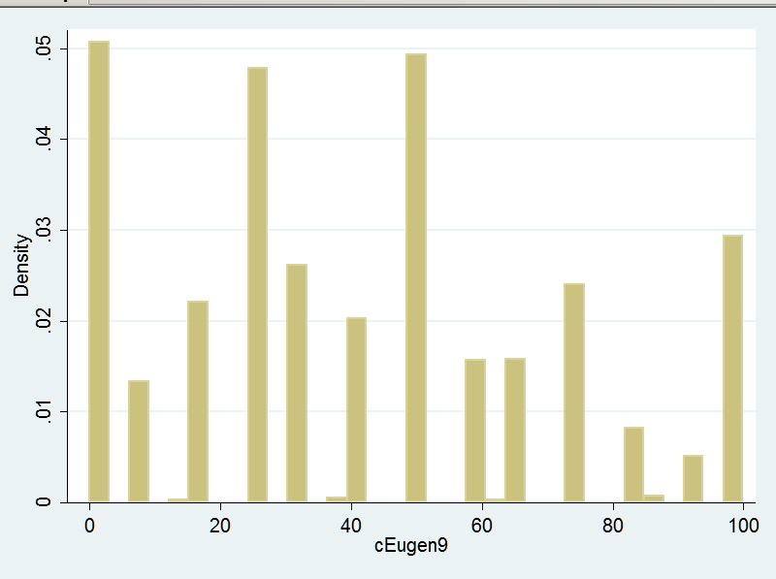

*One independent variable: church going
tab chGoNowQ, m

Church |
going |
(times per |
year) | Freq. Percent Cum.
------------+-----------------------------------
.5 | 638 27.80 27.80
.75 | 343 14.95 42.75
1.5 | 105 4.58 47.32
4 | 300 13.07 60.39
12 | 91 3.97 64.36
30 | 98 4.27 68.63
45 | 121 5.27 73.90
52 | 364 15.86 89.76
140 | 31 1.35 91.11
. | 204 8.89 100.00
------------+-----------------------------------
Total | 2,295 100.00

*Start with an ordinary regression, one independent variable, no interactions

regress cEugen9 chGoNowQ, b
Source | SS df MS Number of obs = 2091
-------------+------------------------------ F( 1, 2089) = 42.74
Model | 38169.3049 1 38169.3049 Prob > F = 0.0000
Residual | 1865410.48 2089 892.968159 R-squared = 0.0201
-------------+------------------------------ Adj R-squared = 0.0196
Total | 1903579.79 2090 910.803727 Root MSE = 29.883

------------------------------------------------------------------------------
cEugen9 | Coef. Std. Err. t P>|t| Beta
-------------+----------------------------------------------------------------
chGoNowQ | -.167011 .025545 -6.54 0.000 -.1416027
_cons | 44.5182 .7788063 57.16 0.000 .
------------------------------------------------------------------------------

*Graph it in Stata (simple graphs are easy in Stata)
twoway ( lfitci cEugen9 chGoNowQ )
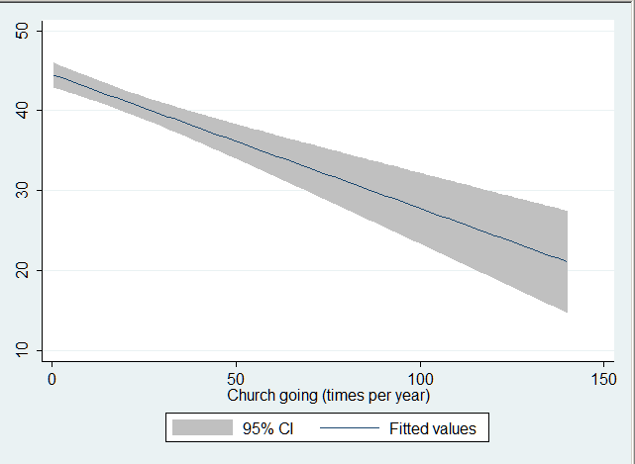

*Predicted values, using Eval4

*First remind ourselves of Eval's way of doing things: (We just need a simple, basic example):
eval4 help
*---------------------------------------------------------------------------------*
WHOLE POPULATION STANDARDIZATION. Version Jan 2009. For help: eval4 help
Run a probit, logit, or any linear model (OLS, xtreg, or anything
for which Stata's predict function works properly with option xb).
Choose: linear, logit, probit. Loop over 1 variable, or optionally 2.
Assumes the whole population should be analyzed (otherwise
analyze a work file restricted to the relevant cases).

SIMPLE EXAMPLES
eval4 linear age "18 50 64"
eval4 probit churchGo "ln(0.5) ln(52)"
eval4 logit age "18 64" status "0 30 35 74 100"

SPECIAL CASES: Interactions, quadratics, sets of dummies, recodes:
that is whenever one variable depends by definition on others.
...etc...

*Now do it for our variables. Its a linear model. Eval4 knows we mean to use the regression we just ran, no need to say more about that. We want predicted values for church attendance; we will go from "never attend" to roughly "once a week", ignoring the very few who go more than that.
eval4 linear chGoNowQ "0 10 20 30 40 50"
*---------------------------------------------------------------------------------*
WHOLE POPULATION STANDARDIZATION. Version Jan 2009. For help: eval4 help
This is a linear model.
I'll call fix_vars, just to be sure it runs OK (it checks dummies too)
Fix_vars ran OK

chGoNowQ Predicted s.e. ci Low ci High Now-prev Now-begin Now/begin
0 44.52 .7788 42.99 46.04 0 0 1
10 42.85 .6748 41.53 44.17 -1.67 -1.67 .9625
20 41.18 .6593 39.89 42.47 -1.67 -3.34 .925
30 39.51 .7379 38.06 40.95 -1.67 -5.01 .8875
40 37.84 .8859 36.1 39.57 -1.67 -6.68 .8499
50 36.17 1.075 34.06 38.27 -1.67 -8.351 .8124
*---------------------------------------------------------------------------------*

*Compare the Eval4 output to the Stata graph.

*Do it again with another independent variable

*Lets look at fundamentalists
*First: who are they? (There is a big literature on this, and also things we can do with our data to sort things out. But for now, lets just take a conventional definition.)

table DnomNow, c(m fundmQ freq)

--------------------------------------------
DnomNow | mean(fundmQ) Freq.
----------------+---------------------------
-1 | 0 192
1. No relig | 0 641
2. AME | 1 7
3. Baptst | 1 273
4. Cath | 0 337
5. C of Christ | 1 74
6. Congreg | 0 14
7. Episcop | 0 40
8. Jewish | 0 64
9. Jehovah Witt | 1 17
10. Hindu | 0 7
11. LDS | 0 19
12. Lutheran | 0 93
13. Method | 0 118
14. Muslim | 0 11
15. Non-demon | 1 225
16. Orthodox | 0 10
17. Pentcost | 1 54
18. Presby | 0 66
19. 7th day | 1 12
20. Pagan | 0 21
--------------------------------------------

tab fundmQ, m
RECODE of |
DnomNow | Freq. Percent Cum.
------------+-----------------------------------
0 | 1,633 71.15 71.15
1 | 662 28.85 100.00
------------+-----------------------------------
Total | 2,295 100.00

*Now the new regression, a graph, and predicted values:

regress cEugen9 fundmQ , b
Source | SS df MS Number of obs = 2295
-------------+------------------------------ F( 1, 2293) = 21.43
Model | 19652.2434 1 19652.2434 Prob > F = 0.0000
Residual | 2102461.45 2293 916.904252 R-squared = 0.0093
-------------+------------------------------ Adj R-squared = 0.0088
Total | 2122113.69 2294 925.071357 Root MSE = 30.28

------------------------------------------------------------------------------
cEugen9 | Coef. Std. Err. t P>|t| Beta
-------------+----------------------------------------------------------------
fundmQ | -6.459149 1.395183 -4.63 0.000 -.0962325
_cons | 43.76403 .7493227 58.40 0.000 .
------------------------------------------------------------------------------

twoway ( lfitci cEugen9 fundmQ )
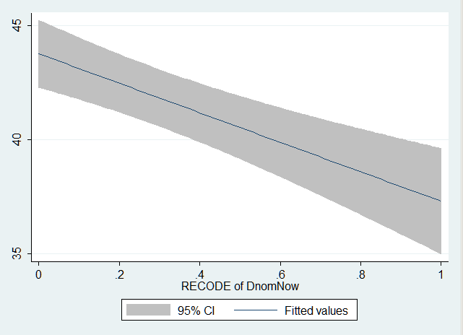

eval4 linear fundmQ "0 1"
*---------------------------------------------------------------------------------*
WHOLE POPULATION STANDARDIZATION. Version Jan 2009. For help: eval4 help
This is a linear model.
I'll call fix_vars, just to be sure it runs OK (it checks dummies too)
Fix_vars ran OK

fundmQ Predicted s.e. ci Low ci High Now-prev Now-begin Now/begin
0 43.76 .7493 42.3 45.23 0 0 1
1 37.3 1.177 35 39.61 -6.459 -6.459 .8524
*---------------------------------------------------------------------------------*

*Two independent variables together

*If they are correlated -- i.e. there is overlap between them -- then taking them only one at a time as we have done so far will exaggerate their influence. Are they correlated?
corr fundmQ chGoNowQ cEugen9
(obs=2091)
| fundmQ chGoNowQ cEugen9
-------------+---------------------------
fundmQ | 1.0000
chGoNowQ | 0.2127 1.0000
cEugen9 | -0.1099 -0.1416 1.0000

Answer: they are correlated, but only a little. So the regressions with each separately will have slightly over-estimated their true importance.

*Now look at both together
regress cEugen9 fundmQ chGoNowQ , b
Source | SS df MS Number of obs = 2091
-------------+------------------------------ F( 2, 2088) = 28.66
Model | 50869.4005 2 25434.7003 Prob > F = 0.0000
Residual | 1852710.39 2088 887.313404 R-squared = 0.0267
-------------+------------------------------ Adj R-squared = 0.0258
Total | 1903579.79 2090 910.803727 Root MSE = 29.788

------------------------------------------------------------------------------
cEugen9 | Coef. Std. Err. t P>|t| Beta
-------------+----------------------------------------------------------------
fundmQ | -5.492197 1.451714 -3.78 0.000 -.083593
chGoNowQ | -.1460418 .0260602 -5.60 0.000 -.1238237
_cons | 45.83044 .8502976 53.90 0.000 .
------------------------------------------------------------------------------

*And for comparison, here again are the single variable results:
regress cEugen9 fundmQ , b
regress cEugen9 chGoNowQ , b
...
cEugen9 | Coef. Std. Err. t P>|t| Beta
-------------+----------------------------------------------------------------
fundmQ | -6.459149 1.395183 -4.63 0.000 -.0962325
_cons | 43.76403 .7493227 58.40 0.000 .
------------------------------------------------------------------------------
...
------------------------------------------------------------------------------
cEugen9 | Coef. Std. Err. t P>|t| Beta
-------------+----------------------------------------------------------------
chGoNowQ | -.167011 .025545 -6.54 0.000 -.1416027
_cons | 44.5182 .7788063 57.16 0.000 .
------------------------------------------------------------------------------

So the single variable regressions modestly over-stated things: the effect of fundmQ and chGoNowQ is more accurately shown in the multiple regression.

*Extend that idea: control for lots of other variables

regress cEugen9 fundmQ chGoNowQ maleQ ageQ edNowQ rural polDem9 lnFamInc, b
Source | SS df MS Number of obs = 1584
-------------+------------------------------ F( 8, 1575) = 17.85
Model | 123337.016 8 15417.127 Prob > F = 0.0000
Residual | 1360223.54 1575 863.633996 R-squared = 0.0831
-------------+------------------------------ Adj R-squared = 0.0785
Total | 1483560.56 1583 937.182918 Root MSE = 29.388

------------------------------------------------------------------------------
cEugen9 | Coef. Std. Err. t P>|t| Beta
-------------+----------------------------------------------------------------
fundmQ | -4.835158 1.685356 -2.87 0.004 -.0725654
chGoNowQ | -.1157187 .0305231 -3.79 0.000 -.0969895
maleQ | 9.489746 1.488888 6.37 0.000 .1550321
ageQ | -.1201485 .0488251 -2.46 0.014 -.0615989
edNowQ | .5940966 .3427608 1.73 0.083 .0443058
rural | -1.67962 1.560574 -1.08 0.282 -.0264207
polDem9 | 11.7243 2.321756 5.05 0.000 .1271608
lnFamInc | -1.299957 .417628 -3.11 0.002 -.0781302
_cons | 36.57025 5.451592 6.71 0.000 .
------------------------------------------------------------------------------

These other controls further reduced the effects, but not by a lot.
Controls for things more closely related to fundamentalism and church attendance (for example, religious beliefs) might well do more.

*Interactions? -- a first look
*Now another possibility: we speculate that there may be something special about fundamentalists who regularly go to church -- not just that they are less keen on eugenics than folk in other denominations (although that is true) nor just because they go more often to church than other folk (although that too is true), but something more.
*> Perhaps going to church with other fundamentalists reaffirms and reinforces their beliefs, insulating them from secular pressures in the wider non-fundamentalist worlds.
*> Or putting the same idea the other way around, perhaps fundamentalists who only rarely go to church are more exposed to secular pressures from the wider world, and that undermines and devalues their beliefs.
*> Those arguments (and others like them) suggest an INTERACTION.
*> A word to the wise: interactions are often very interesting, not to mention publishable (see, for example, "National Context, Parental Socialization, and Religious Belief: Results From 15 Nations", Jonathan Kelley and Nan Dirk De Graaf, American Sociological Review 1997). But they are rare. Treasure them when you find them!

*> First, lets explore the possibility by running the regression twice, once for fundamentalists and once for others. (Note the strange double equal sign "==" that Stata requires in an "if" clause.)

regress cEugen9 chGoNowQ if fundmQ==1, b
These are the fundamentalists:
...
------------------------------------------------------------------------------
cEugen9 | Coef. Std. Err. t P>|t| Beta
-------------+----------------------------------------------------------------
chGoNowQ | -.0758921 .0423297 -1.79 0.073 -.0712486
_cons | 38.5949 1.555252 24.82 0.000 .
------------------------------------------------------------------------------
regress cEugen9 chGoNowQ if fundmQ==0, b
Everyone else here:
...
------------------------------------------------------------------------------
cEugen9 | Coef. Std. Err. t P>|t| Beta
-------------+----------------------------------------------------------------
chGoNowQ | -.184524 .0328523 -5.62 0.000 -.1455813
_cons | 46.33085 .8981201 51.59 0.000 .
------------------------------------------------------------------------------

It looks like there is an interaction, with church going mattering more for non-fundamentalists

*Alternatively, we could do it the other way around, comparing those who rarely go to church with those who go a lot. We find the same interaction, in a different disguise:

regress cEugen9 fundmQ if chGoNowQ <= 2, b
Attend church twice a year or less:
...
------------------------------------------------------------------------------
cEugen9 | Coef. Std. Err. t P>|t| Beta
-------------+----------------------------------------------------------------
fundmQ | -9.835638 2.34774 -4.19 0.000 -.1262264
_cons | 47.02314 1.007512 46.67 0.000 .
------------------------------------------------------------------------------

regress cEugen9 fundmQ if chGoNowQ > 2, b
Attend church more than twice a year:
...
------------------------------------------------------------------------------
cEugen9 | Coef. Std. Err. t P>|t| Beta
-------------+----------------------------------------------------------------
fundmQ | -2.542783 1.792453 -1.42 0.156 -.0407987
_cons | 39.89848 1.10804 36.01 0.000 .
------------------------------------------------------------------------------

*Interactions -- significance test, using a multiplicative interaction variable

*There is another way to do this, which is harder to set up but has some advantages. It gives a significance test, and is easily extended to add lots of other controls.
*First we do the simple version. Begin by making an interaction variable (we actually made it earlier, so we drop the original -- otherwise Stata fusses -- and remake it, just for clarity):

drop chXfund
gen chXfund = fundmQ * chGoNowQ

*Here is what we made:
tab chXfund
chXfund | Freq. Percent Cum.
------------+-----------------------------------
0 | 1,459 69.78 69.78
.5 | 76 3.63 73.41
.75 | 101 4.83 78.24
1.5 | 23 1.10 79.34
4 | 98 4.69 84.03
12 | 39 1.87 85.89
30 | 56 2.68 88.57
45 | 54 2.58 91.15
52 | 174 8.32 99.47
140 | 11 0.53 100.00
------------+-----------------------------------
Total | 2,091 100.00

table chGoNowQ fundmQ , c(m chXfund )
----------------------
Church |
going | RECODE of
(times | DnomNow -- this is fundmQ, poorly labeled
per year) | 0 1
----------+-----------
.5 | 0 .5
.75 | 0 .75
1.5 | 0 1.5
4 | 0 4
12 | 0 12
30 | 0 30
45 | 0 45
52 | 0 52
140 | 0 140
----------------------

*now the test:
regress cEugen9 fundmQ chGoNowQ chXfund , b
Source | SS df MS Number of obs = 2091
-------------+------------------------------ F( 3, 2087) = 20.46
Model | 54396.4075 3 18132.1358 Prob > F = 0.0000
Residual | 1849183.38 2087 886.048578 R-squared = 0.0286
-------------+------------------------------ Adj R-squared = 0.0272
Total | 1903579.79 2090 910.803727 Root MSE = 29.767

------------------------------------------------------------------------------
cEugen9 | Coef. Std. Err. t P>|t| Beta
-------------+----------------------------------------------------------------
fundmQ | -7.735949 1.83554 -4.21 0.000 -.1177436
chGoNowQ | -.184524 .0324067 -5.69 0.000 -.1564514
chXfund | .1086319 .0544482 2.00 0.046 .0675102
_cons | 46.33085 .8859367 52.30 0.000 .
------------------------------------------------------------------------------

The difference is significant, but only just (and we have not yet controlled for age, gender, and other variables).

*Predicted values for the interaction using Eval4

*You need to tell subroutine fix_vars about the interaction you just created -- Eval4 will need that information.
*Recall it was created by: gen chXfund = fundmQ * chGoNowQ
*You need to put that into fix_vars, adding it to whatever was already in fix_vars and changing the "gen" to "quietly replace". Like this:

capture program drop fix_vars /*Drop previous version, so can replace */
program define fix_vars

/* compute interactions & quadratics: "quietly replace" */
quietly display " "

/*interactions, as previously defined but here with "quietly replace" not "gen" */
quietly replace chXfund = fundmQ * chGoNowQ

end

*Now re-run fix_vars (pop it into Stata's "do file editor" and run from there). Stata will then show:
. do "C:\Users\Puck\AppData\Local\Temp\STD03000000.tmp"

. capture program drop fix_vars /*Drop previous version, so can replace */

. program define fix_vars
1.
. /* compute interactions & quadratics: "quietly replace" */
. quietly display " "
2.
. /*interactions, as previously defined but here with "quietly replace" not "gen" */
. quietly replace chXfund = fundmQ * chGoNowQ
3.
. end

.
end of do-file

*Now run Eval4, asking about both fundamentalists and church going. We will re-run the regression first, just for drill, and then eval4:
regress cEugen9 fundmQ chGoNowQ chXfund , b
eval4 linear chGoNowQ "0 10 20 30 40 50" fundmQ "0 1"
*---------------------------------------------------------------------------------*
WHOLE POPULATION STANDARDIZATION. Version Jan 2009. For help: eval4 help
This is a linear model.
I'll call fix_vars, just to be sure it runs OK (it checks dummies too)
Fix_vars ran OK

*---------- fundmQ = 0
chGoNowQ Predicted s.e. ci Low ci High Now-prev Now-begin Now/begin
0 46.33 .8859 44.59 48.07 0 0 1
10 44.49 .7853 42.95 46.02 -1.845 -1.845 .9602
20 42.64 .8116 41.05 44.23 -1.845 -3.69 .9203
30 40.8 .9543 38.92 42.67 -1.845 -5.536 .8805
40 38.95 1.172 36.65 41.25 -1.845 -7.381 .8407
50 37.1 1.43 34.3 39.91 -1.845 -9.226 .8009

*---------- fundmQ = 1
chGoNowQ Predicted s.e. ci Low ci High Now-prev Now-begin Now/begin
0 38.59 1.608 35.44 41.75 0 0 1
10 37.84 1.351 35.19 40.48 -.7589 -.7589 .9803
20 37.08 1.203 34.72 39.43 -.7589 -1.518 .9607
30 36.32 1.205 33.96 38.68 -.7589 -2.277 .941
40 35.56 1.357 32.9 38.22 -.7589 -3.036 .9213
50 34.8 1.616 31.63 37.97 -.7589 -3.795 .9017
*---------------------------------------------------------------------------------*

>>Note that the bits in green are close to what we got from the two separate regressions (compare them with the slopes in the separate regressions).
>>Church going matters more for non-fundamentalists than for fundamentalists, as we have seen before.

*Graphing the predicted values
*We will graph the predicted values in Excel (for multiple regressions that is easier than Stata).
*First get data for fundamentalists into Excel.
* #1. Highlight it in Stata
* #2. EDIT/ COPY TABLE
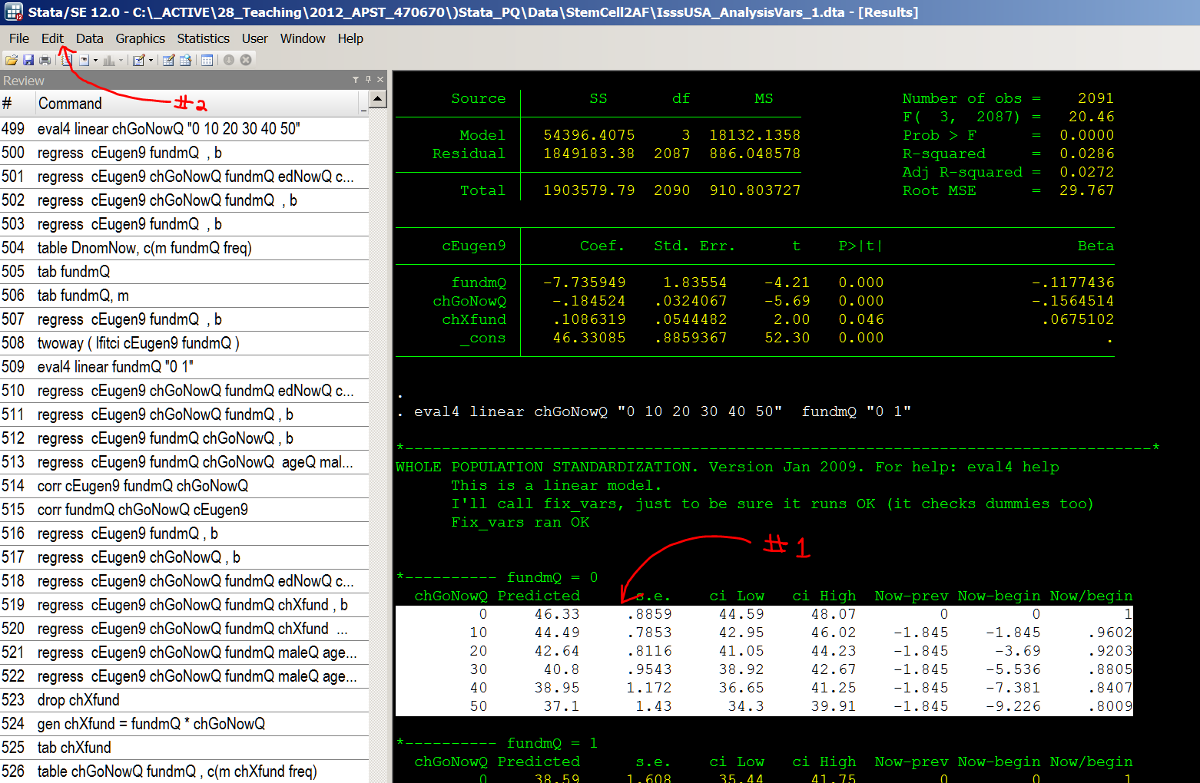

* Paste into Excel (note that "COPY TABLE" gets it into separate columns, as desired):
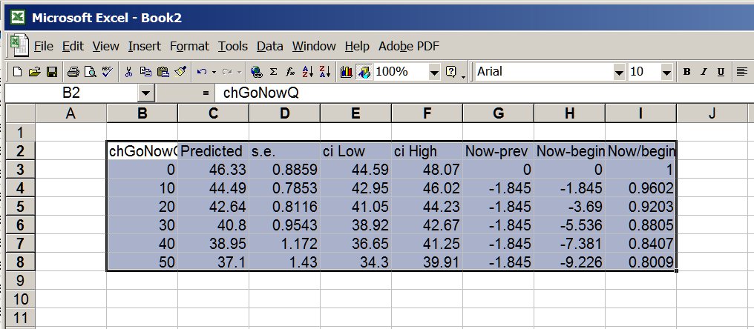

*Label them "Fundamentalists" (so you don't forget). Then copy and paste in the data for non-fundamentalists:
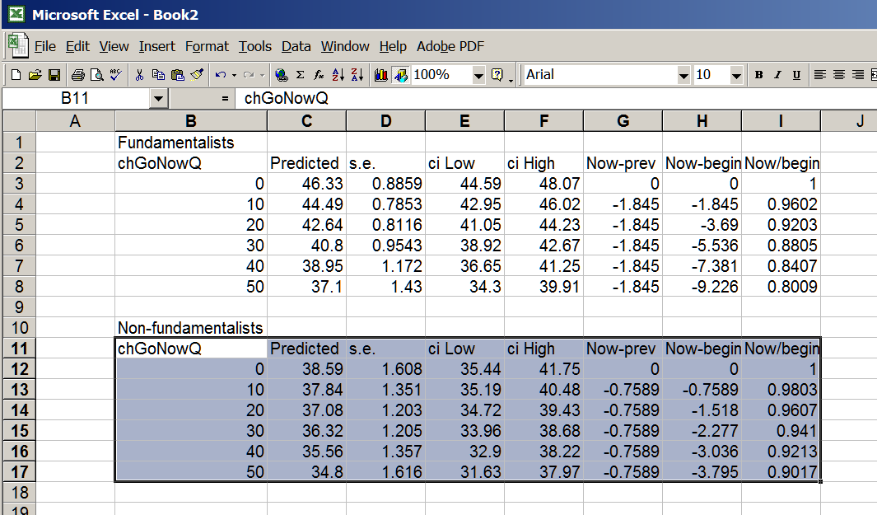

*Now (1 and 2) copy the predicted values into a form that Excel's graphing routines want, as follows
* (3) label the two columns (in yellow in the screen shot).
* (4) Then select the new stuff:
* (5) Choose the Excel "graph" icon
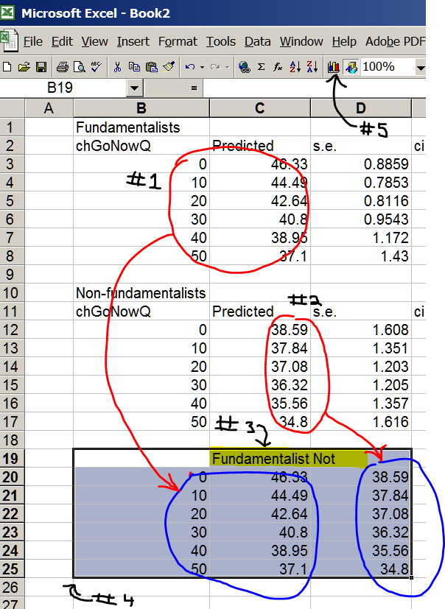

*Now choose the line graph shown, and click through to "Finish":
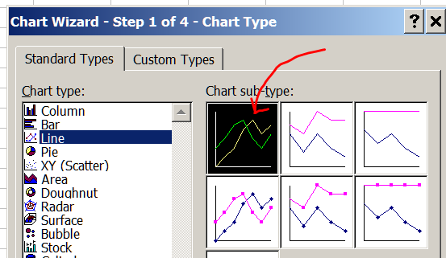

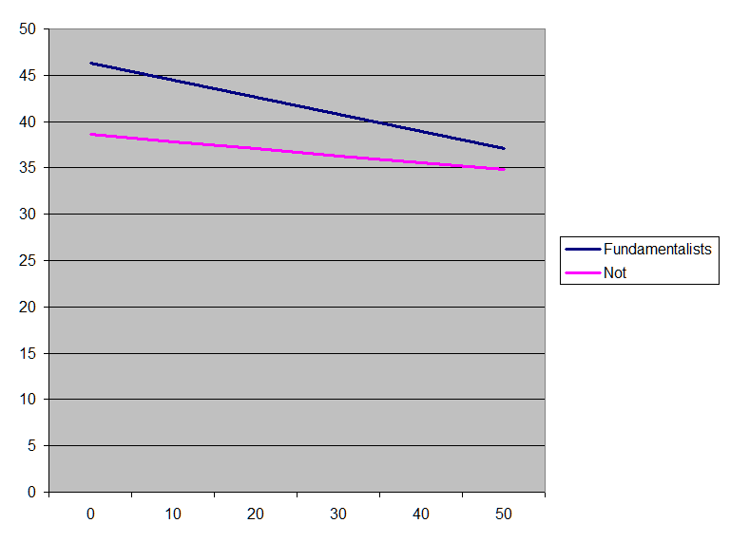

*You can then edit it to make it clearer

*Interaction, with lots of controls

regress cEugen9 fundmQ chGoNowQ chXfund maleQ ageQ edNowQ rural polDem9 lnFamInc, b
Source | SS df MS Number of obs = 1584
-------------+------------------------------ F( 9, 1574) = 16.85
Model | 130365.913 9 14485.1014 Prob > F = 0.0000
Residual | 1353194.65 1574 859.717056 R-squared = 0.0879
-------------+------------------------------ Adj R-squared = 0.0827
Total | 1483560.56 1583 937.182918 Root MSE = 29.321

------------------------------------------------------------------------------
cEugen9 | Coef. Std. Err. t P>|t| Beta
-------------+----------------------------------------------------------------
fundmQ | -8.563515 2.127853 -4.02 0.000 -.12852
chGoNowQ | -.1781501 .0374722 -4.75 0.000 -.1493163
chXfund | .1767736 .0618232 2.86 0.004 .1086128
maleQ | 9.339498 1.486437 6.28 0.000 .1525775
ageQ | -.1145249 .048754 -2.35 0.019 -.0587158
edNowQ | .6056134 .3420063 1.77 0.077 .0451647
rural | -1.704229 1.557055 -1.09 0.274 -.0268078
polDem9 | 11.6516 2.316624 5.03 0.000 .1263723
lnFamInc | -1.28411 .4167167 -3.08 0.002 -.0771777
_cons | 37.05379 5.441844 6.81 0.000 .
------------------------------------------------------------------------------

The interaction is still significant (a pleasant surprise, given the general way with interactions)

*You get predicted values (same as before)
eval4 linear chGoNowQ "0 10 20 30 40 50" fundmQ "0 1"
*---------------------------------------------------------------------------------*
WHOLE POPULATION STANDARDIZATION. Version Jan 2009. For help: eval4 help
This is a linear model.
I'll call fix_vars, just to be sure it runs OK (it checks dummies too)
Fix_vars ran OK

*---------- fundmQ = 0
chGoNowQ Predicted s.e. ci Low ci High Now-prev Now-begin Now/begin
0 46.5 2.062 42.46 50.54 0 0 1
10 44.72 2.005 40.79 48.65 -1.782 -1.782 .9617
20 42.93 2.018 38.98 46.89 -1.782 -3.563 .9234
30 41.15 2.1 37.04 45.27 -1.782 -5.345 .8851
40 39.37 2.243 34.98 43.77 -1.781 -7.126 .8467
50 37.59 2.435 32.82 42.36 -1.782 -8.908 .8084

*---------- fundmQ = 1
chGoNowQ Predicted s.e. ci Low ci High Now-prev Now-begin Now/begin
0 37.93 2.589 32.86 43.01 0 0 1
10 37.92 2.381 33.25 42.59 -.01377 -.01377 .9996
20 37.91 2.269 33.46 42.35 -.01376 -.02753 .9993
30 37.89 2.268 33.45 42.34 -.01377 -.0413 .9989
40 37.88 2.377 33.22 42.54 -.01376 -.05506 .9985
50 37.87 2.581 32.81 42.92 -.01376 -.06882 .9982
*---------------------------------------------------------------------------------*

*Copy them into Excel, and graph (same as before)
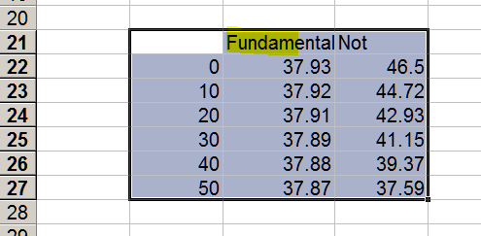

*This time we will pause to do some labeling, and dress things up a bit afterwards as well.

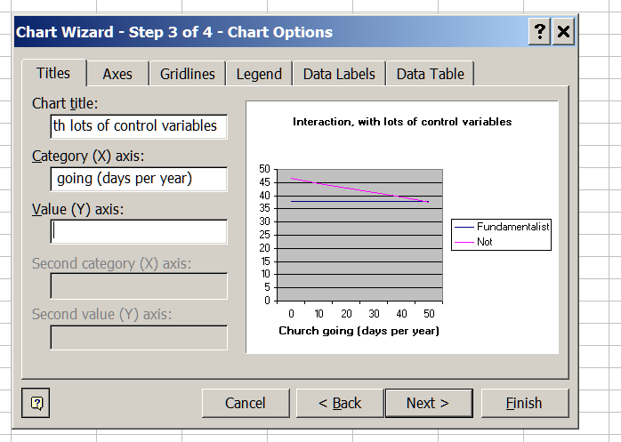

*The interaction is much like we had before, without controls, but a bit nicer.
*Describe what we have here, in plain English.

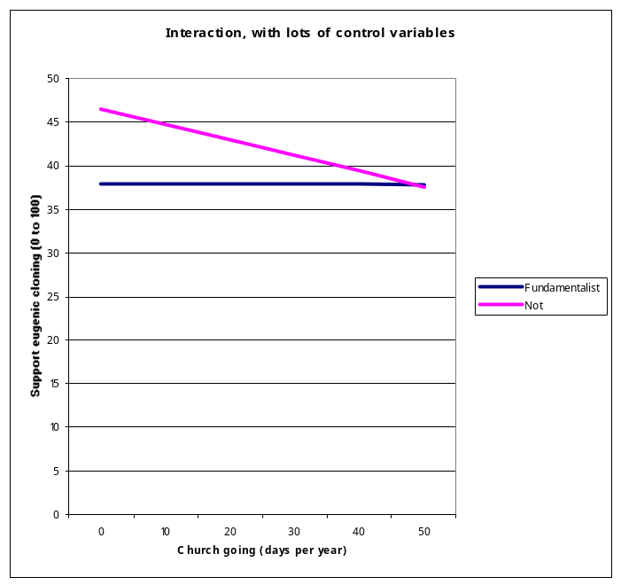

*Having made a nice, tarted-up graph, you might want to save it and then re-use it on other data. For my (older) version of Excel select the chart and then in the menu (entirely un-intuitively):
* CHART/ CHART TYPE/ CUSTOM TYPES/ USER DEFINED/ ADD
* Then give it a name.
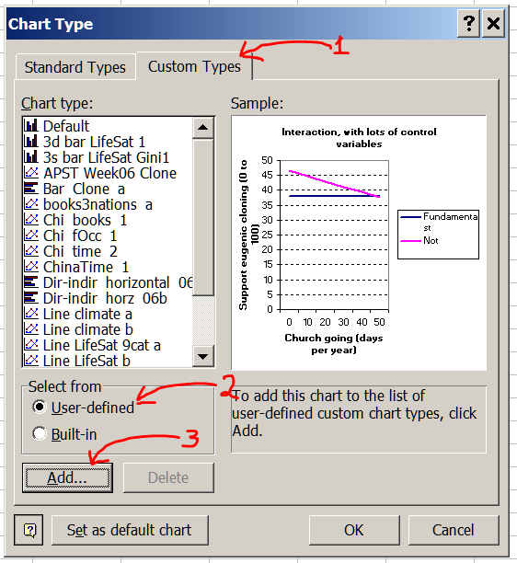

*Week 6, continued: Curvilinear effects. New example
*Most effects are linear, at least to a reasonable approximation. So we have to hunt about a bit to find one that is curvilinear. Lets look at education and income: economic theory (and common sense) suggest that going from (say) 12 years of education to 13 won't increase income as much as going from 16 to 17, or from 19 to 20.

*Is the relation linear?
*First, lets take a quick peek:

table edNowQ, c(m famInc freq)
--------------------------------------
RECODE of |
EdNow | mean(famInc) Freq.
----------+---------------------------
10 | 26.36486 42 -- too few cases; mostly ignore
11 | 20.42 31 -- too few cases; mostly ignore
12 | 35.24776 444
13 | 45.32854 729 -- gain about $10k from year before
14 | 50.74279 255
16.5 | 70.57381 453 -- gain about $20k from before. But that is
2.5 years of ed, so we are gaining about $8k a year
18 | 85.32971 166 -- gain about $15k for 1.5 years of ed, or
something like $10k a year
22 | 136.5484 35 -- gain about $51k for 4 years of ed,
something like $13k a year
--------------------------------------
Its not linear, but a table like this is hard to read.

*Graph it in Excel -- just like we did for predicted values.
*In Stata, "COPY TABLE"
*Then paste it into Excel
*Label the column of means (its column "C" in the example)
*Select the first two rows.
*Be sure there is NOTHING in the upper left corner -- otherwise Excel gets confused
*Click the graph icon, as before.
*If you have saved the previous graph (the one you tarted up) as a named type, use that (give new title and axis labels. You will also need to change the Y-axis scale by hand: click on it, FORMAT AXIS/ SCALE/ enter 150 for the top category)

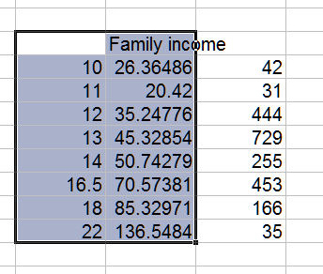

*This is what you get:
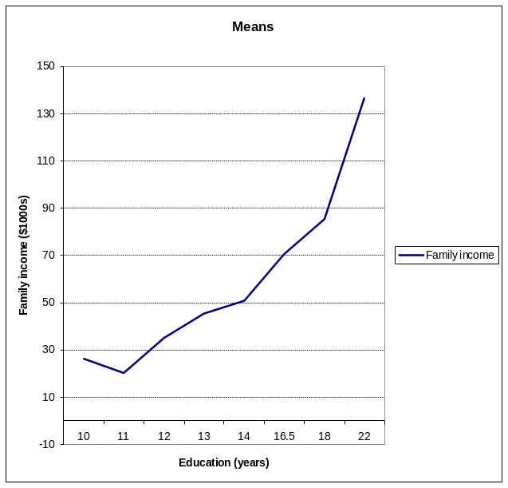

* A bit messy! I don't the drop at year 11. There are not a lot of cases there so it might be bad luck, but still I don't like it.
* To re-iterate a point we have made before: bigger samples are easier to analyze! We have 2000 cases here (not bad) but it would be easier if we had 20,000. Then if the "drop" was still there, we would know it was real, not chance, and so something we have to worry about.

*An annoyance with Excel is that it treats each education category as an equal interval above the one below -- i.e. it pays no attention to our "years" label. That is OK for 10, 11, 12, 13 and 14. But after that we have larger gaps, so its not quite right. The regression (to come) will be right.
* Smooth things by adding a trend line.
* Select the chart and then CHART/ ADD TREND LINE.
* Then choose type POLYNOMIAL OF ORDER 2.

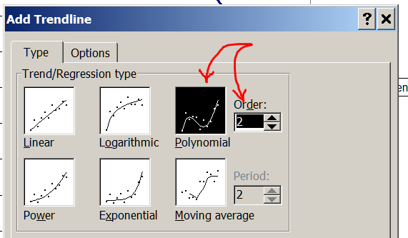

*That gives:
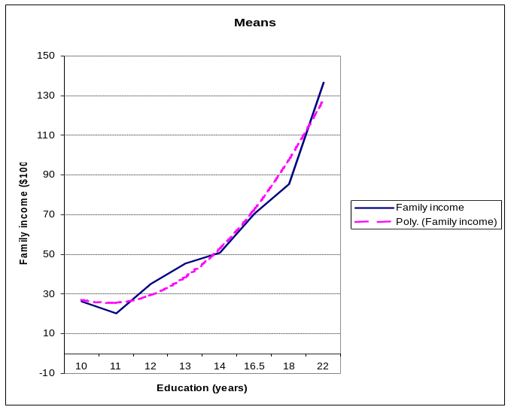

*We assume (slightly reluctantly, in this example) that a smooth curve of this sort is a reasonable summary. The most common choice of curve is a quadratic (a "polynomial of order 2" in Excel jargon). There are other choices, but we will work with that for now. Its usually a good choice.

*Create a quadratic variable (we actually did it earlier; here we repeat)
drop edNowSq
gen edNowSq = edNowQ^2

*This is what we have created
tab edNowSq, m
edNowSq | Freq. Percent Cum.
------------+-----------------------------------
100 | 42 1.83 1.83
121 | 31 1.35 3.18
144 | 444 19.35 22.53
169 | 729 31.76 54.29
196 | 255 11.11 65.40
272.25 | 453 19.74 85.14
324 | 166 7.23 92.37
484 | 35 1.53 93.90
. | 140 6.10 100.00
------------+-----------------------------------
Total | 2,295 100.00

table edNowQ, c(m edNowSq sd edNowSq freq)
-------------------------------------------------------
RECODE of |
EdNow | mean(edNowSq) sd(edNowSq) Freq.
----------+--------------------------------------------
10 | 100 0 42
11 | 121 0 31
12 | 144 0 444
13 | 169 0 729
14 | 196 0 255
16.5 | 272.25 0 453
18 | 324 0 166
22 | 484 0 35
-------------------------------------------------------

*Is there statistically significant curvature?
*to be realistic, we will control for some of the "usual suspects" -- age, gender, and occupational status.

regress famInc edNowQ edNowSq status maleQ ageQ , beta

There is significant curvature, but only just

Source | SS df MS Number of obs = 1450
-------------+------------------------------ F( 5, 1444) = 40.68
Model | 600152.377 5 120030.475 Prob > F = 0.0000
Residual | 4260561.65 1444 2950.52746 R-squared = 0.1235
-------------+------------------------------ Adj R-squared = 0.1204
Total | 4860714.02 1449 3354.53004 Root MSE = 54.319

------------------------------------------------------------------------------
famInc | Coef. Std. Err. t P>|t| Beta
-------------+----------------------------------------------------------------
edNowQ | -10.52542 6.342226 -1.66 0.097 -.4198902
edNowSq | .5400023 .2057438 2.62 0.009 .6623626
status | .3350793 .0701189 4.78 0.000 .1395924
maleQ | -.0079687 2.875327 -0.00 0.998 -.0000687
ageQ | .1823257 .0932067 1.96 0.051 .0492288
_cons | 66.60159 47.67987 1.40 0.163 .
------------------------------------------------------------------------------

*graph it

*To graph it, we first have to tell subroutine fix_vars (and therefore Eval4) just what quadratic variable we have made.
*Recall we made it with: gen edNowSq = edNowQ^2

*So we add that to our existing fix_vars, and re-run it (via the do-file editor):

capture program drop fix_vars /*Drop previous version, so can replace */
program define fix_vars

/* compute interactions & quadratics: "quietly replace" */
quietly display " "

/*interactions, as previously defined but here with "quietly replace" not "gen" */
quietly replace chXfund = fundmQ * chGoNowQ

quietly replace edNowSq = edNowQ^2

end

. do "C:\Users\Puck\AppData\Local\Temp\STD03000000.tmp"

. capture program drop fix_vars /*Drop previous version, so can replace */

. program define fix_vars
1.
. /* compute interactions & quadratics: "quietly replace" */
. quietly display " "
2.
. /*interactions, as previously defined but here with "quietly replace" not "gen" */
. quietly replace chXfund = fundmQ * chGoNowQ
3.
. quietly replace edNowSq = edNowQ^2
4.
. end

*Re-run the regression (just to be pedantic) and then run Eval4
regress famInc edNowQ edNowSq status maleQ ageQ , beta
eval4 linear edNowQ "10 11 12 13 14 15 16 17 18 19 20"

Source | SS df MS Number of obs = 1450
-------------+------------------------------ F( 5, 1444) = 40.68
Model | 600152.377 5 120030.475 Prob > F = 0.0000
Residual | 4260561.65 1444 2950.52746 R-squared = 0.1235
-------------+------------------------------ Adj R-squared = 0.1204
Total | 4860714.02 1449 3354.53004 Root MSE = 54.319

------------------------------------------------------------------------------
famInc | Coef. Std. Err. t P>|t| Beta
-------------+----------------------------------------------------------------
edNowQ | -10.52542 6.342226 -1.66 0.097 -.4198902
edNowSq | .5400023 .2057438 2.62 0.009 .6623626
status | .3350793 .0701189 4.78 0.000 .1395924
maleQ | -.0079687 2.875327 -0.00 0.998 -.0000687
ageQ | .1823257 .0932067 1.96 0.051 .0492288
_cons | 66.60159 47.67987 1.40 0.163 .
------------------------------------------------------------------------------

*---------------------------------------------------------------------------------*
WHOLE POPULATION STANDARDIZATION. Version Jan 2009. For help: eval4 help
This is a linear model.
I'll call fix_vars, just to be sure it runs OK (it checks dummies too)
Fix_vars ran OK -- Eval is happy with our revised fix_vars

edNowQ Predicted s.e. ci Low ci High Now-prev Now-begin Now/begin
10 41.44 6.21 29.27 53.61 0 0 1
11 42.25 4.536 33.36 51.14 .8146 .8146 1.02
12 44.15 3.483 37.32 50.98 1.895 2.709 1.065
13 47.12 3.073 41.1 53.15 2.975 5.684 1.137
14 51.18 3.097 45.11 57.25 4.055 9.739 1.235
15 56.31 3.263 49.92 62.71 5.135 14.87 1.359
16 62.53 3.431 55.8 69.25 6.215 21.09 1.509
17 69.82 3.628 62.71 76.93 7.295 28.38 1.685
18 78.2 4.01 70.34 86.06 8.375 36.76 1.887
19 87.65 4.774 78.29 97.01 9.455 46.21 2.115
20 98.19 6.045 86.34 110 10.53 56.75 2.369
*---------------------------------------------------------------------------------*
Around high school graduation, a year of education is worth a couple of thousand dollars in future income. Around the end of graduate school, its more like ten thousand.

*Graph it in Excel in the usual way (we have also added a linear trend line to show how curve and linear compare -- note where the discrepancies are)
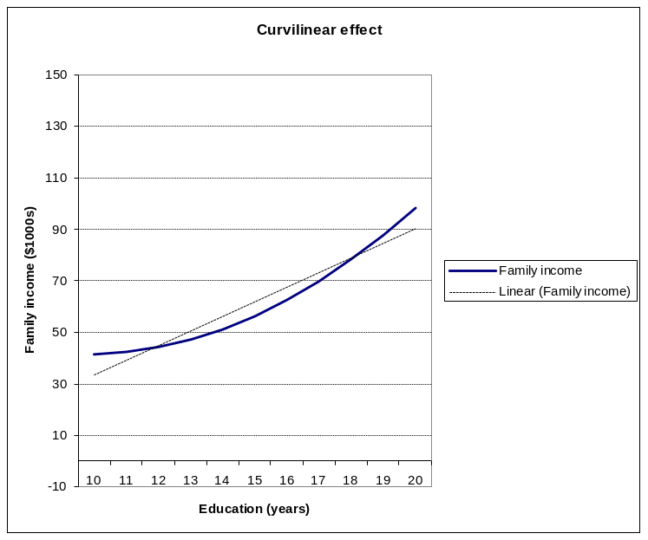

*Week 7: Logistic and Probit regressions
* When you have a dichotomous dependent/response variable, these are the methods to use. Which one you choose is mainly a matter of convenience in your field. With extreme splits neither does very well unless your theory has led you to exactly the right set of predictors, but the probit tends to do a little better. (Check out Chapter 7 in the Hamilton "Regression with graphics" text.)

*This approach to learning logistic and probit regression will involve dichotomous variables with different splits, and we'll also do comparisons to OLS to see what the gains are.

*Case #1: Dichotomous dependent/response variable, but not an extreme split

*Analyze with conventional OLS first, just to see what is up

regress married chGoNowQ maleM ageM edNow2M rural polDem9, b
Source | SS df MS Number of obs = 2054
-------------+------------------------------ F( 6, 2047) = 20.39
Model | 28.8623622 6 4.8103937 Prob > F = 0.0000
Residual | 482.999858 2047 .235954987 R-squared = 0.0564
-------------+------------------------------ Adj R-squared = 0.0536
Total | 511.86222 2053 .249324023 Root MSE = .48575

------------------------------------------------------------------------------
married | Coef. Std. Err. t P>|t| Beta
-------------+----------------------------------------------------------------
chGoNowQ | .0014473 .0004363 3.32 0.001 .0735864
maleM | -.0547296 .0215475 -2.54 0.011 -.0546363
ageM | .0055162 .0006871 8.03 0.000 .1749014
edNow2M | .006194 .0047415 1.31 0.192 .0284918
rural | .0312748 .02263 1.38 0.167 .0300856
polDem9 | -.124615 .033389 -3.73 0.000 -.0826324
_cons | .1840771 .0822769 2.24 0.025 .
------------------------------------------------------------------------------

*This gets predicted values for each case -- convenient!
predict olsHat1

list married olsHat1 ageM in 1/10
+---------------------------+
| married olsHat1 ageM |
|---------------------------|
1. | 0 .26539 28 |
2. | 0 .3827111 31 |
3. | 1 .4091021 49 |
4. | 1 .3939637 42 |
5. | 0 .3503894 34 |
|---------------------------|
6. | 0 .6229985 72 |
7. | 0 .4059684 30 |
8. | 0 .5455852 36 |
9. | 1 .4950664 49 |
10. | 1 .467046 43 |
+---------------------------+

*Lets look at another way of finding R-squared
corr married olsHat1
| married olsHat1
-------------+------------------
married | 1.0000
olsHat1 | 0.2375 1.0000
display .2375^2
.05640625 -- compare with the OLS above

*Now graph it: Run eval4, "copy table" and paste into Excel, make graph:
eval4 linear ageM "20 30 40 50 60 70"
*---------------------------------------------------------------------------------*
WHOLE POPULATION STANDARDIZATION. Version Jan 2009. For help: eval4 help
This is a linear model.
I'll call fix_vars, just to be sure it runs OK (it checks dummies too)
Fix_vars ran OK

ageM Predicted s.e. ci Low ci High Now-prev Now-begin Now/begin
20 .3255 .03157 .2636 .3874 0 0 1
30 .3806 .02813 .3255 .4358 .05516 .05516 1.169
40 .4358 .0261 .3846 .487 .05516 .1103 1.339
50 .491 .02585 .4403 .5416 .05516 .1655 1.508
60 .5461 .02742 .4924 .5999 .05516 .2206 1.678
70 .6013 .03051 .5415 .6611 .05516 .2758 1.847
*---------------------------------------------------------------------------------*

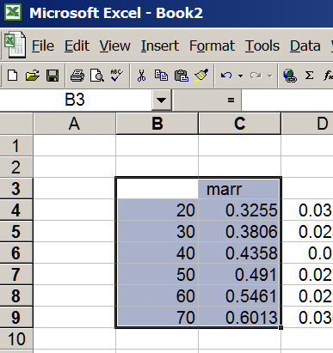

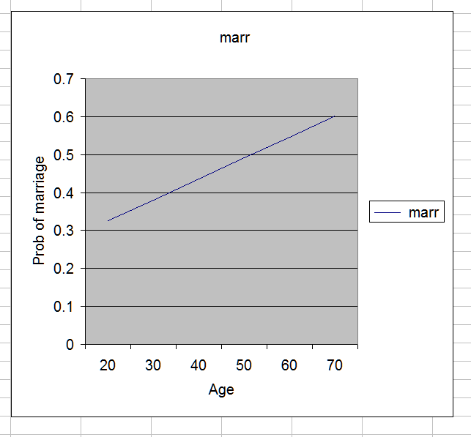

*Any curvilinearity?

*Lets take a quick look at the means:
gen age10 = round( ageM, 10)
. tab age10
age10 | Freq. Percent Cum.
------------+-----------------------------------
20 | 220 9.59 9.59 -- this is really 15 to 25
30 | 364 15.86 25.45 -- and this 25 to 35 or so
40 | 413 18.00 43.44
50 | 605 26.36 69.80
60 | 324 14.12 83.92
70 | 297 12.94 96.86
80 | 66 2.88 99.74
90 | 6 0.26 100.00 -- not enough cases
------------+-----------------------------------
Total | 2,295 100.00

table age10, c(m married freq)

----------------------------------------
age10 | mean(married) Freq.
----------+-----------------------------
20 | .1409091 220
30 | .4120879 364
40 | .5012106 413
50 | .3966942 605 -- odd, out of sequence. I don't like that!
60 | .5555556 324
70 | .5690235 297
80 | .5151515 66
90 | .3333333 6
----------------------------------------

*Graph it in Excel. Add a trend line in Excel (polynomial, degree 2, ie our usual quadratic)
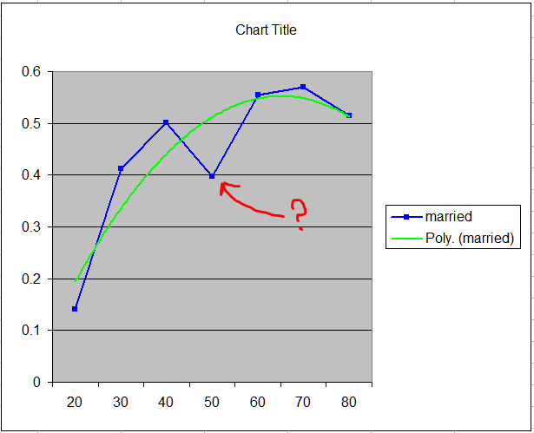

*Deal with the curvature systematically (as we did last week)

*First, we are going to roughly center age on the way to squaring it, because age itself can take on pretty substantial values, so their squares are very large. Rescoring those values as differences from a number near the mean before squaring them makes the squared values smaller, so there is less rounding error in calculations using them.

gen ageMSq = (ageM -40)^2

*now tell fix_vars about it:
*No need to edit out last week's interaction chXfund -- leave it in case we want it later

*Run the revised fix_vars from the Stata do-file editor.
capture program drop fix_vars /*Drop previous version, so can replace */
program define fix_vars

/* compute interactions & quadratics: "quietly replace" */
quietly display " "
quietly replace edNowSq = edNowQ^2
quietly replace ageMSq = (ageM -40)^2

/*interactions, as previously defined but here with "quietly replace" not "gen" */
quietly replace chXfund = fundmQ * chGoNowQ

end

*Now our regression, with a proper test of the curvature:
regress married chGoNowQ maleM ageM ageMSq edNow2M rural polDem9, b
Source | SS df MS Number of obs = 2054
-------------+------------------------------ F( 7, 2046) = 23.54
Model | 38.1464912 7 5.44949874 Prob > F = 0.0000
Residual | 473.715729 2046 .231532614 R-squared = 0.0745
-- look how much bigger R-squared is
-------------+------------------------------ Adj R-squared = 0.0714
Total | 511.86222 2053 .249324023 Root MSE = .48118

------------------------------------------------------------------------------
married | Coef. Std. Err. t P>|t| Beta
-------------+----------------------------------------------------------------
chGoNowQ | .0014517 .0004322 3.36 0.001 .073808
maleM | -.0533131 .0213458 -2.50 0.013 -.0532222
ageM | .0092809 .0009037 10.27 0.000 .2942701
ageMSq | -.0002572 .0000406 -6.33 0.000 -.1807948
-- this is the right sig test
edNow2M | .0081668 .0047072 1.73 0.083 .0375663
rural | .0348956 .0224242 1.56 0.120 .0335688
polDem9 | -.1367353 .0331299 -4.13 0.000 -.0906694
_cons | .0603565 .0838113 0.72 0.472 .
------------------------------------------------------------------------------

*Now for predicted values: noticeably better than what we had before
predict olsHat2
list married olsHat1 olsHat2 ageM in 1/10
corr married olsHat1 olsHat2 ageM
+--------------------------------------+
| married olsHat1 olsHat2 ageM |
|--------------------------------------|
1. | 0 .26539 .2260525 28 |
2. | 0 .3827111 .3868366 31 |
3. | 1 .4091021 .4739023 49 |
4. | 1 .3939637 .462032 42 |
5. | 0 .3503894 .3624285 34 |
|--------------------------------------|
6. | 0 .6229985 .5217903 72 |
7. | 0 .4059684 .3946553 30 |
8. | 0 .5455852 .5664732 36 |
9. | 1 .4950664 .5610106 49 |
10. | 1 .467046 .5259852 43 |
+--------------------------------------+

. corr married olsHat1 olsHat2 ageM
| married olsHat1 olsHat2 ageM
-------------+------------------------------------
married | 1.0000
olsHat1 | 0.2375 1.0000
olsHat2 | 0.2730 0.8698 1.0000
ageM | 0.1917 0.8071 0.7021 1.0000

*Graph them in Excel, in the usual way. Up to age 80 this time.

eval4 linear ageM "20 30 40 50 60 70 80"
*---------------------------------------------------------------------------------*
WHOLE POPULATION STANDARDIZATION. Version Jan 2009. For help: eval4 help
This is a linear model.
I'll call fix_vars, just to be sure it runs OK (it checks dummies too)
Fix_vars ran OK

ageM Predicted s.e. ci Low ci High Now-prev Now-begin Now/begin
20 .1981 .0373 .125 .2712 0 0 1
30 .3681 .02796 .3133 .4229 .17 .17 1.858
40 .4866 .0271 .4335 .5397 .1185 .2885 2.456
50 .5537 .0275 .4998 .6076 .06709 .3556 2.795
60 .5694 .02743 .5156 .6231 .01566 .3712 2.874
70 .5336 .03211 .4707 .5965 -.03577 .3355 2.693
80 .4464 .04786 .3526 .5402 -.0872 .2483 2.253
*---------------------------------------------------------------------------------*

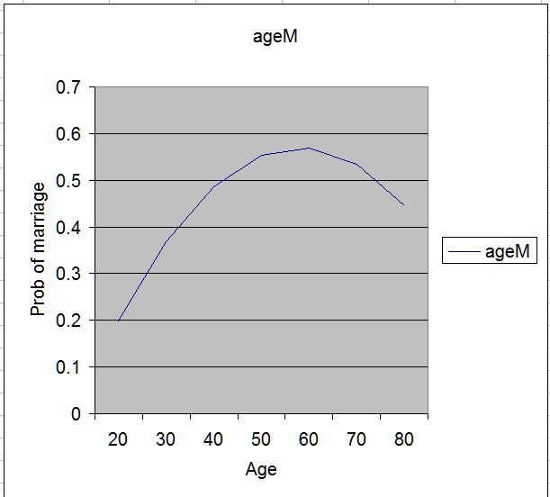

*Now a probit regression
*Now the probit regression, starting without the age squared term (just as we started the OLS without it):

probit married chGoNowQ maleM ageM edNow2M rural polDem9

It looks quite different than the OLS, but is actually quite similar in the end
Iteration 0: log likelihood = -1420.447
Iteration 1: log likelihood = -1361.2785
Iteration 2: log likelihood = -1361.2095
Iteration 3: log likelihood = -1361.2095

Probit regression Number of obs = 2054
LR chi2(6) = 118.48
Prob > chi2 = 0.0000
Log likelihood = -1361.2095 Pseudo R2 = 0.0417

------------------------------------------------------------------------------
married | Coef. Std. Err. z P>|z| [95% Conf. Interval]
-------------+----------------------------------------------------------------
chGoNowQ | .003755 .0011375 3.30 0.001 .0015255 .0059845
maleM | -.1437437 .0566409 -2.54 0.011 -.2547579 -.0327295
ageM | .0144116 .0018248 7.90 0.000 .010835 .0179882
edNow2M | .0160778 .0124471 1.29 0.196 -.0083181 .0404736
rural | .0807265 .0594317 1.36 0.174 -.0357575 .1972106
polDem9 | -.3216707 .0872925 -3.68 0.000 -.4927609 -.1505805
_cons | -.825758 .2161993 -3.82 0.000 -1.249501 -.4020151
------------------------------------------------------------------------------

*This gets predicted values for each case, just as for OLS -- convenient! Note the "pr" option, which asks for predicted probabilities (the default is something else)
predict probHat1, pr

list married olsHat1 olsHat2 probHat1 ageM in 1/10
Not actually very different from our earlier OLS estimates
+-------------------------------------------------+
| married olsHat1 olsHat2 probHat1 ageM |
|-------------------------------------------------|
1. | 0 .26539 .2260525 .2701299 28 |
2. | 0 .3827111 .3868366 .3787908 31 |
3. | 1 .4091021 .4739023 .4061627 49 |
4. | 1 .3939637 .462032 .3908046 42 |
5. | 0 .3503894 .3624285 .3485191 34 |
|-------------------------------------------------|
6. | 0 .6229985 .5217903 .6262043 72 |
7. | 0 .4059684 .3946553 .4026269 30 |
8. | 0 .5455852 .5664732 .5467135 36 |
9. | 1 .4950664 .5610106 .4948178 49 |
10. | 1 .467046 .5259852 .4655033 43 |
+-------------------------------------------------+

*Any extra curvilinearity in the probit?
probit married chGoNowQ maleM ageM ageMSq edNow2M rural polDem9
Lots!
Iteration 0: log likelihood = -1420.447
Iteration 1: log likelihood = -1340.2063
Iteration 2: log likelihood = -1339.9431
Iteration 3: log likelihood = -1339.9431

Probit regression Number of obs = 2054
LR chi2(7) = 161.01
Prob > chi2 = 0.0000
Log likelihood = -1339.9431 Pseudo R2 = 0.0567

------------------------------------------------------------------------------
married | Coef. Std. Err. z P>|z| [95% Conf. Interval]
-------------+----------------------------------------------------------------
chGoNowQ | .0037754 .0011396 3.31 0.001 .0015419 .0060089
maleM | -.1454243 .0570418 -2.55 0.011 -.2572243 -.0336244
ageM | .0256922 .0025779 9.97 0.000 .0206395 .0307449
ageMSq | -.0007221 .0001118 -6.46 0.000 -.0009412 -.0005031
edNow2M | .0212936 .0125598 1.70 0.090 -.0033231 .0459103
rural | .0882706 .0599048 1.47 0.141 -.0291407 .2056819
polDem9 | -.3596551 .0880474 -4.08 0.000 -.5322248 -.1870853
_cons | -1.203333 .2261728 -5.32 0.000 -1.646624 -.7600428
------------------------------------------------------------------------------

*Graph it using Eval4 and Excel, as before.
eval4 probit ageM "20 30 40 50 60 70 80"
*---------------------------------------------------------------------------------*
WHOLE POPULATION STANDARDIZATION.
ageM Predicted s.e. ci Low ci High Now-prev Now-begin Now/begin
20 .2046 .02927 .1519 .2667 0 0 1
30 .3591 .02782 .3058 .4149 .1545 .1545 1.755
40 .4848 .02801 .4299 .5397 .1258 .2802 2.37
50 .5569 .0281 .5011 .6113 .07211 .3523 2.722
60 .5725 .02784 .5171 .6262 .01556 .3679 2.798
70 .5321 .03294 .467 .5961 -.04041 .3275 2.601
80 .4351 .04858 .3417 .5322 -.09698 .2305 2.127
*---------------------------------------------------------------------------------*

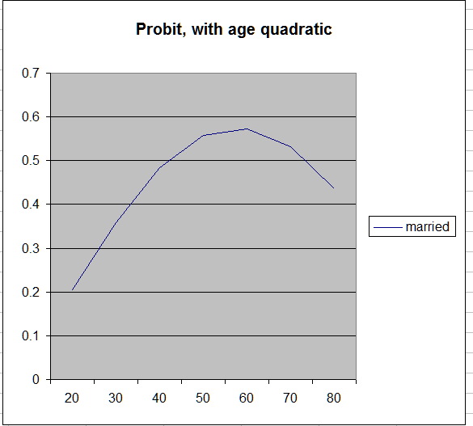

*In case you thought this was pretty familiar, lets compare it systematically with OLS. Get the predicted value, in the usual way:

predict probHat2, pr

list married olsHat1 olsHat2 probHat1 probHat2 ageM in 1/10
+------------------------------------------------------------+
| married olsHat1 olsHat2 probHat1 probHat2 ageM |
|------------------------------------------------------------|
1. | 0 .26539 .2260525 .2701299 .2279259 28 |
2. | 0 .3827111 .3868366 .3787908 .3756584 31 |
3. | 1 .4091021 .4739023 .4061627 .4741499 49 |
4. | 1 .3939637 .462032 .3908046 .4591648 42 |
5. | 0 .3503894 .3624285 .3485191 .3558584 34 |
|------------------------------------------------------------|
6. | 0 .6229985 .5217903 .6262043 .52037 72 |
7. | 0 .4059684 .3946553 .4026269 .3834852 30 |
8. | 0 .5455852 .5664732 .5467135 .5655384 36 |
9. | 1 .4950664 .5610106 .4948178 .567229 49 |
10. | 1 .467046 .5259852 .4655033 .5292059 43 |
+------------------------------------------------------------+

corr married olsHat1 olsHat2 probHat1 probHat2 ageM
| married olsHat1 olsHat2 probHat1 probHat2 ageM
-------------+------------------------------------------------------
married | 1.0000
olsHat1 | 0.2375 1.0000
olsHat2 | 0.2730 0.8698 1.0000
probHat1 | 0.2369 0.9997 0.8687 1.0000
probHat2 | 0.2700 0.8658 0.9987 0.8654 1.0000
ageM | 0.1917 0.8071 0.7021 0.8095 0.7035 1.0000
-- and what, pray tell, does r=.998 imply?

*Here is the difference graphically -- ie nothing!
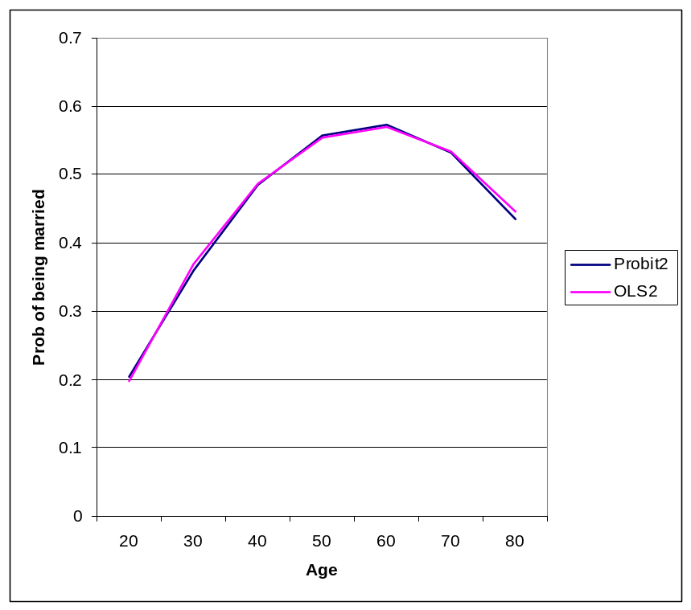

*Now a Logistic regression

*here is the one without age squared; we won't bother looking at it
logit married chGoNowQ maleM ageM edNow2M rural polDem9
predict logitHat1, pr

*Now add age squared
logit married chGoNowQ maleM ageM ageMSq edNow2M rural polDem9
Iteration 0: log likelihood = -1420.447
Iteration 1: log likelihood = -1340.72
Iteration 2: log likelihood = -1340.5272
Iteration 3: log likelihood = -1340.5272

Logistic regression Number of obs = 2054
LR chi2(7) = 159.84
Prob > chi2 = 0.0000
Log likelihood = -1340.5272 Pseudo R2 = 0.0563

------------------------------------------------------------------------------
married | Coef. Std. Err. z P>|z| [95% Conf. Interval]
-------------+----------------------------------------------------------------
chGoNowQ | .0062209 .0018869 3.30 0.001 .0025227 .0099191
maleM | -.229121 .0924879 -2.48 0.013 -.410394 -.0478481
ageM | .041087 .004233 9.71 0.000 .0327906 .0493835
ageMSq | -.0011544 .0001819 -6.35 0.000 -.0015109 -.0007979
edNow2M | .0355592 .0204543 1.74 0.082 -.0045306 .0756489
rural | .1464454 .0970351 1.51 0.131 -.0437399 .3366308
polDem9 | -.5806996 .1426165 -4.07 0.000 -.8602228 -.3011765
_cons | -1.948962 .3708395 -5.26 0.000 -2.675794 -1.22213
------------------------------------------------------------------------------

*save the predicted value for later
predict logitHat2, pr

eval4 logit ageM "20 30 40 50 60 70 80"
*---------------------------------------------------------------------------------*
WHOLE POPULATION STANDARDIZATION.
ageM Predicted s.e. ci Low ci High Now-prev Now-begin Now/begin
20 .2117 .02837 .1612 .2724 0 0 1
30 .3604 .02792 .3072 .4167 .1487 .1487 1.703
40 .485 .02832 .4294 .5404 .1246 .2733 2.291
50 .5568 .0283 .5004 .6113 .07183 .3451 2.63
60 .5723 .028 .5164 .6261 .0155 .3606 2.704
70 .5322 .03317 .4665 .5965 -.04013 .3205 2.514
80 .4357 .0487 .3425 .5334 -.09648 .224 2.058
*---------------------------------------------------------------------------------*

*Graph in Excel, as before. Here are the graphs for OLS, probit, and logit (all with age squared). It takes very sharp eyes to see any difference!
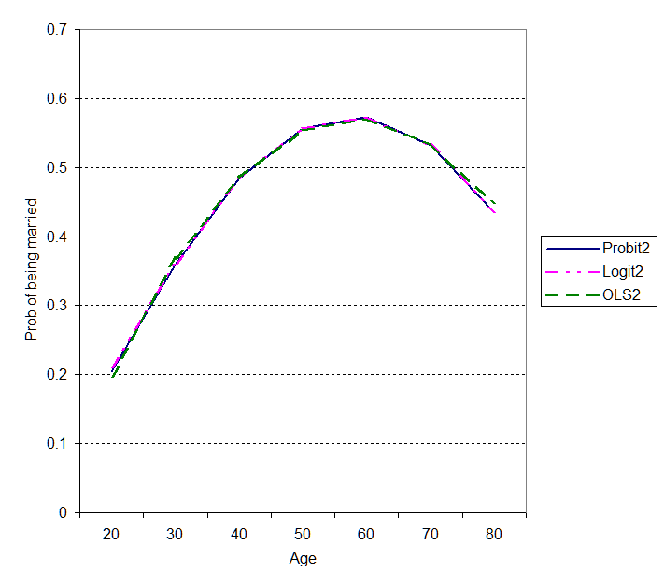

*Case #2: Dichotomous dependent/response variable, with an extreme split (90% vs 10% or so)

*Dependent/response variable defined: works in a professional job
**tab status
**recode status (100=1)(10 / 90=0)(*=.), gen( prof)
**tab prof, m
**table status, c(m prof freq) m
Kelleys Worldwide |
Status Score | Freq. Percent Cum.
------------------------+-----------------------------------
10. Farmer | 9 0.48 0.48
14. Unskilled worker | 98 5.26 5.74
24. Semi-skilled worker | 94 5.04 10.78
26. Service (hi & low) | 195 10.46 21.24
37. Skilled worker | 183 9.82 31.06
42. Sales (hi & low) | 238 12.77 43.83
49. Clerical (hi & low) | 372 19.96 63.79
70. Technical | 311 16.68 80.47
75. Administrative | 167 8.96 89.43
100. Professional | 197 10.57 100.00
------------------------+-----------------------------------
Total | 1,864 100.00

RECODE of |
status |
(Kelleys |
Worldwide |
Status |
Score) | Freq. Percent Cum.
------------+-----------------------------------
0 | 1,667 72.64 72.64
1 | 197 8.58 81.22
. | 431 18.78 100.00 -- lots of folk do not work
------------+-----------------------------------
Total | 2,295 100.00

------------------------------------------------
Kelleys Worldwide |
Status Score | mean(prof) Freq.
------------------------+-----------------------
10. Farmer | 0 9
14. Unskilled worker | 0 98
24. Semi-skilled worker | 0 94
26. Service (hi & low) | 0 195
37. Skilled worker | 0 183
42. Sales (hi & low) | 0 238
49. Clerical (hi & low) | 0 372
70. Technical | 0 311
75. Administrative | 0 167
100. Professional | 1 197
------------------------------------------------

*Who gets professional jobs: OLS estimates (no quadratic in ed)
*Here we use edNowQ, a slightly different version of education. The version we were using earlier paid some attention to people's educational plans. So for example, if someone was in college, of the usual age, and said they planned to finish college, we believed them and coded them into the graduate category. That is probably right for re attitudes, interest, life-style, etc. But for the analysis of current job that we are to do here, we need their actual current education, not their plans (eg you need to have your teaching certificate in hand before taking a teaching job). That is in edNowQ.

*The original questions:
Education now, and your future plans...
Now:
10th grade or less
11th grade
GED
12th grade
Some college, no degree
Associate degree
BA, BS
MA, MS, LLB
MD
PhD

Plans:
(No more, I'm finished.)
High school diploma/ GED
Associate degree
BA, BS
MA, MS, LLB
MD
PhD

*What we are using here:
tab edNowQ, m
RECODE of |
EdNow | Freq. Percent Cum.
------------+-----------------------------------
10 | 42 1.83 1.83
11 | 31 1.35 3.18
12 | 444 19.35 22.53
13 | 729 31.76 54.29
14 | 255 11.11 65.40
16.5 | 453 19.74 85.14
18 | 166 7.23 92.37
22 | 35 1.53 93.90
. | 140 6.10 100.00
------------+-----------------------------------

regress prof married chGoNowQ maleM ageM edNowQ rural polDem9, beta
Source | SS df MS Number of obs = 1776
-------------+------------------------------ F( 7, 1768) = 59.48
Model | 31.5896453 7 4.51280647 Prob > F = 0.0000
Residual | 134.139521 1768 .07587077 R-squared = 0.1906
-------------+------------------------------ Adj R-squared = 0.1874
Total | 165.729167 1775 .093368545 Root MSE = .27545

------------------------------------------------------------------------------
prof | Coef. Std. Err. t P>|t| Beta
-------------+----------------------------------------------------------------
married | .0022735 .0135153 0.17 0.866 .0037143
chGoNowQ | .0004646 .0002679 1.73 0.083 .0387635
maleM | .0211198 .013142 1.61 0.108 .03448
ageM | .0005405 .0004339 1.25 0.213 .0276229
edNowQ | .0569776 .0029539 19.29 0.000 .424771
rural | .0237321 .0138308 1.72 0.086 .0373366
polDem9 | .0005352 .0203232 0.03 0.979 .0005859
_cons | -.760925 .0475275 -16.01 0.000 .
------------------------------------------------------------------------------

predict olsHat3
eval4 probit edNowQ "10 12 14 16 18 20 22"

*---------------------------------------------------------------------------------*
WHOLE POPULATION STANDARDIZATION.
edNowQ Predicted s.e. ci Low ci High Now-prev Now-begin Now/begin
10 .4451 .008379 .4287 .4615 0 0 1
12 .4903 .007307 .476 .5047 .04528 .04528 1.102
14 .5358 .006793 .5224 .549 .0454 .09068 1.204
16 .5807 .006988 .5669 .5943 .04494 .1356 1.305
18 .6246 .007751 .6093 .6397 .04391 .1795 1.403
20 .667 .00879 .6495 .684 .04235 .2219 1.499
22 .7073 .009854 .6877 .7263 .04032 .2622 1.589
*---------------------------------------------------------------------------------*

*Who gets professional jobs: probit estimates

probit prof married chGoNowQ maleM ageM edNowQ rural polDem9

Iteration 0: log likelihood = -593.4376
Iteration 1: log likelihood = -446.90323
Iteration 2: log likelihood = -440.26127
Iteration 3: log likelihood = -440.23862
Iteration 4: log likelihood = -440.23862

Probit regression Number of obs = 1776
LR chi2(7) = 306.40
Prob > chi2 = 0.0000
Log likelihood = -440.23862 Pseudo R2 = 0.2582

------------------------------------------------------------------------------
prof | Coef. Std. Err. z P>|z| [95% Conf. Interval]
-------------+----------------------------------------------------------------
married | .0671814 .0951551 0.71 0.480 -.1193191 .2536819
chGoNowQ | .0021291 .0016976 1.25 0.210 -.0011981 .0054564
maleM | .1205948 .0947907 1.27 0.203 -.0651915 .3063811
ageM | .0043075 .0031777 1.36 0.175 -.0019206 .0105356
edNowQ | .3079578 .0206867 14.89 0.000 .2674125 .348503
rural | .1526669 .0996606 1.53 0.126 -.0426643 .3479981
polDem9 | -.0606992 .1381297 -0.44 0.660 -.3314283 .21003
_cons | -6.324576 .3728632 -16.96 0.000 -7.055374 -5.593777
------------------------------------------------------------------------------

predict probHat3, pr

eval4 probit edNowQ "10 12 14 16 18 20 22"
*---------------------------------------------------------------------------------*
WHOLE POPULATION STANDARDIZATION.
edNowQ Predicted s.e. ci Low ci High Now-prev Now-begin Now/begin
10 .002093 .00129 .0006924 .005748 0 0 1
12 .01207 .004807 .005574 .02442 .009973 .009973 5.764
14 .04986 .0133 .02909 .08124 .0378 .04777 23.82
16 .1498 .02821 .1013 .2119 .09995 .1477 71.57
18 .3343 .04646 .248 .4301 .1844 .3322 159.7
20 .5718 .05733 .4563 .681 .2376 .5697 273.2
22 .7853 .05074 .6724 .8713 .2135 .7832 375.2
*---------------------------------------------------------------------------------*

*...logit estimates
logit prof married chGoNowQ maleM ageM edNowQ rural polDem9
eval4 logit edNowQ "10 12 14 16 18 20 22"
*---------------------------------------------------------------------------------*
WHOLE POPULATION STANDARDIZATION.
edNowQ Predicted s.e. ci Low ci High Now-prev Now-begin Now/begin
10 .004608 .001784 .002289 .009283 0 0 1
12 .01498 .004621 .008438 .02655 .01037 .01037 3.251
14 .0475 .01169 .02964 .07547 .03252 .04289 10.31
16 .1399 .02778 .09409 .203 .09239 .1353 30.36
18 .3445 .05316 .2475 .4559 .2046 .3399 74.76
20 .6282 .06374 .4946 .7444 .2837 .6236 136.3
22 .8453 .04497 .7376 .9139 .2171 .8407 183.4
*---------------------------------------------------------------------------------*

predict lgtHat3, pr

*Graph all. Note that logit and probit have a built-in curve.
*Probit and logit are very similar, OLS is way off.
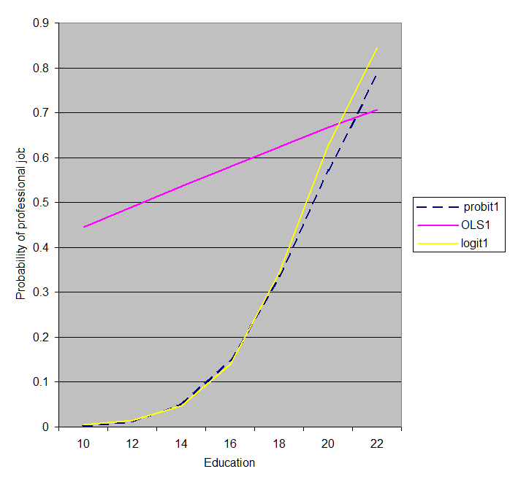

. corr prof probHat3 lgtHat3 olsHat3
(obs=1776)
| prof probHat3 lgtHat3 olsHat3
-------------+------------------------------------
prof | 1.0000
probHat3 | 0.4679 1.0000
lgtHat3 | 0.4696 0.9978 1.0000
olsHat3 | 0.4366 0.9311 0.9120 1.0000
Probit & logit clearly better here, OLS worse. But this way of putting it (with correlations) rather flatters OLS -- the graph is clearer.

*Case #2, cont: Dichotomous with an extreme split, but allow curvilinearity in educ.

*OLS: lots of curvilinearity
regress prof married chGoNowQ maleM ageM edNowQ edNowSq rural polDem9, beta
Source | SS df MS Number of obs = 1776
-------------+------------------------------ F( 8, 1767) = 58.21
Model | 34.5654007 8 4.32067508 Prob > F = 0.0000
Residual | 131.163766 1767 .074229636 R-squared = 0.2086
-------------+------------------------------ Adj R-squared = 0.2050
Total | 165.729167 1775 .093368545 Root MSE = .27245

------------------------------------------------------------------------------
prof | Coef. Std. Err. t P>|t| Beta
-------------+----------------------------------------------------------------
married | .0044101 .0133726 0.33 0.742 .007205
chGoNowQ | .000441 .000265 1.66 0.096 .0367968
maleM | .0159943 .0130242 1.23 0.220 .0261122
ageM | .0006647 .0004296 1.55 0.122 .0339735
edNowQ | -.1289223 .0295059 -4.37 0.000 -.9611224
edNowSq | .0060852 .0009611 6.33 0.000 1.390788
rural | .0209353 .0136875 1.53 0.126 .0329366
polDem9 | -.0041814 .0201159 -0.21 0.835 -.0045777
_cons | .6205234 .223192 2.78 0.005 .
------------------------------------------------------------------------------
predict olsHat4
eval4 linear edNowQ "10 12 14 16 18 20 22"

*Probit: but no obvious curvilinearity here
probit prof married chGoNowQ maleM ageM edNowQ edNowSq rural polDem9
Iteration 0: log likelihood = -593.4376
Iteration 1: log likelihood = -447.42328
Iteration 2: log likelihood = -440.17369
Iteration 3: log likelihood = -440.10196
Iteration 4: log likelihood = -440.10196

Probit regression Number of obs = 1776
LR chi2(8) = 306.67
Prob > chi2 = 0.0000
Log likelihood = -440.10196 Pseudo R2 = 0.2584

------------------------------------------------------------------------------
prof | Coef. Std. Err. z P>|z| [95% Conf. Interval]
-------------+----------------------------------------------------------------
married | .0664265 .0952429 0.70 0.486 -.1202462 .2530992
chGoNowQ | .0021374 .0016971 1.26 0.208 -.0011888 .0054637
maleM | .1235261 .0950494 1.30 0.194 -.0627674 .3098196
ageM | .0041962 .0031898 1.32 0.188 -.0020557 .0104482
edNowQ | .4112855 .1988069 2.07 0.039 .0216311 .8009399
edNowSq | -.003224 .0061627 -0.52 0.601 -.0153027 .0088548
rural | .1554566 .0999853 1.55 0.120 -.040511 .3514241
polDem9 | -.0598454 .1382005 -0.43 0.665 -.3307133 .2110226
_cons | -7.132624 1.592886 -4.48 0.000 -10.25462 -4.010624
------------------------------------------------------------------------------
predict prbtHat4
eval4 probit edNowQ "10 12 14 16 18 20 22"

*Logit, continued. Some curvilinearity for ed here.
logit prof married chGoNowQ maleM ageM edNowQ edNowSq rural polDem9
Logistic regression Number of obs = 1776
LR chi2(8) = 311.76
Prob > chi2 = 0.0000
Log likelihood = -437.55663 Pseudo R2 = 0.2627

------------------------------------------------------------------------------
prof | Coef. Std. Err. z P>|z| [95% Conf. Interval]
-------------+----------------------------------------------------------------
married | .1012172 .1779149 0.57 0.569 -.2474895 .449924
chGoNowQ | .0045561 .0030532 1.49 0.136 -.0014281 .0105403
maleM | .1923622 .1773966 1.08 0.278 -.1553288 .5400531
ageM | .0095601 .0059691 1.60 0.109 -.0021392 .0212593
edNowQ | 1.47562 .4030231 3.66 0.000 .685709 2.26553
edNowSq | -.027009 .012125 -2.23 0.026 -.0507736 -.0032444
rural | .2832371 .1885153 1.50 0.133 -.0862461 .6527203
polDem9 | -.0373163 .2570127 -0.15 0.885 -.5410519 .4664194
_cons | -19.17244 3.351953 -5.72 0.000 -25.74215 -12.60273
------------------------------------------------------------------------------
predict logitHat4
eval4 logit edNowQ "10 12 14 16 18 20 22"

*Compare and graph
>> Very similar, but OLS better than before (now that it has curvature in education) but still not quite as good as logit or probit.
>> Maybe: logit a tiny bit better than probit here??
corr prof probHat3 lgtHat3 olsHat3 prbtHat4 logitHat4 olsHat4
(obs=1776)
| prof probHat3 lgtHat3 olsHat3 prbtHat4 logitH~4 olsHat4
-------------+---------------------------------------------------------------
prof | 1.0000
probHat3 | 0.4679 1.0000
lgtHat3 | 0.4696 0.9978 1.0000
olsHat3 | 0.4366 0.9311 0.9120 1.0000
prbtHat4 | 0.4693 0.9996 0.9959 0.9381 1.0000
logitHat4 | 0.4764 0.9961 0.9927 0.9390 0.9977 1.0000
olsHat4 | 0.4567 0.9890 0.9826 0.9560 0.9890 0.9822 1.0000

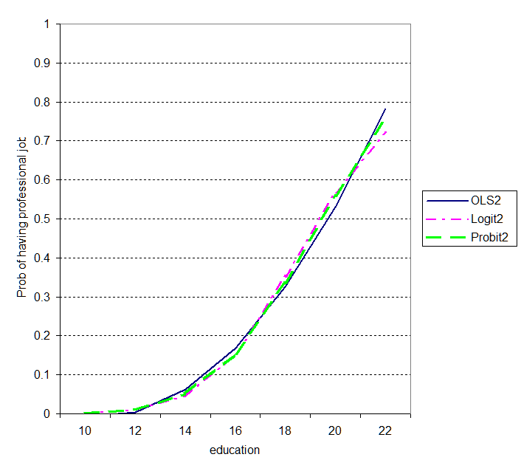

*Week 8/9: Logit/probit continued

*Case #3: Vote
ptyVote
Who did you vote for in the last presidential election?
1 McCain
2 Did not vote, strongly preferred McCain
3 Did not vote, preferred McCain
4 Did not vote, had no preference
5 Did not vote, preferred Obama
6 Did not vote, strongly preferred Obama
7 Obama

tab ptyVote

ptyVote | Freq. Percent Cum.
------------+-----------------------------------
-1 | 151 6.58 6.58
1 | 708 30.85 37.43
2 | 69 3.01 40.44
3 | 63 2.75 43.18
4 | 213 9.28 52.46
5 | 126 5.49 57.95
6 | 118 5.14 63.09
7 | 847 36.91 100.00
------------+-----------------------------------
Total | 2,295 100.00

recode ptyVote (1 2 3 4= 0)(5 6 7=1)(else = .), gen(Obama )
label variable Obama "Preferred Obama (vs McCain or no preference)"
tab Obama, m
table ptyVote, c(m Obama freq )

*Explore with OLS
regress Obama status married chGoNowQ maleM ageM edNowQ rural , beta
Source | SS df MS Number of obs = 1407
-------------+------------------------------ F( 8, 1398) = 8.65
Model | 16.5843216 8 2.0730402 Prob > F = 0.0000
Residual | 335.164079 1398 .239745407 R-squared = 0.0471
-------------+------------------------------ Adj R-squared = 0.0417
Total | 351.748401 1406 .250176672 Root MSE = .48964

------------------------------------------------------------------------------
Obama | Coef. Std. Err. t P>|t| Beta
-------------+----------------------------------------------------------------
status | -.0007272 .0006434 -1.13 0.259 -.0350575
-- surprising -- looks like occupation does not matter??
married | -.0313881 .0314299 -1.00 0.318 -.0311037
chGoNowQ | -.0030503 .0005113 -5.97 0.000 -.1604617
maleM | -.038294 .0263976 -1.45 0.147 -.0381426
ageM | -.0014369 .0008923 -1.61 0.108 -.0445313
edNowQ | .0114913 .0067933 1.69 0.091 .0531745
rural | -.0963936 .0274297 -3.51 0.000 -.0928691
lnFamInc | -.0080053 .0083732 -0.96 0.339 -.0293814
_cons | .5927204 .0914003 6.48 0.000 .
------------------------------------------------------------------------------

*Explore occupational status
tab status, m

Kelleys Worldwide |
Status Score | Freq. Percent Cum.
------------------------+-----------------------------------
10. Farmer | 9 0.39 0.39
14. Unskilled worker | 98 4.27 4.66
24. Semi-skilled worker | 94 4.10 8.76
26. Service (hi & low) | 195 8.50 17.25
37. Skilled worker | 183 7.97 25.23
42. Sales (hi & low) | 238 10.37 35.60
49. Clerical (hi & low) | 372 16.21 51.81
70. Technical | 311 13.55 65.36
75. Administrative | 167 7.28 72.64
100. Professional | 197 8.58 81.22
. | 431 18.78 100.00
------------------------+-----------------------------------
Total | 2,295 100.00

table status, c(m Obama freq)
Nothing here

--------------------------------------------------
Kelleys Worldwide |
Status Score | mean(Obama) Freq.
------------------------+-------------------------
10. Farmer | .4444444 9
14. Unskilled worker | .5773196 98
24. Semi-skilled worker | .4782609 94
26. Service (hi & low) | .5803109 195
37. Skilled worker | .489011 183
42. Sales (hi & low) | .517094 238
49. Clerical (hi & low) | .4932249 372
70. Technical | .5032258 311
75. Administrative | .4666667 167
100. Professional | .5025381 197
--------------------------------------------------

*Look at religion again, as its promising

regress Obama married chGoNowQ fundmQ maleM ageM edNowQ rural status , beta

Source | SS df MS Number of obs = 1761
-------------+------------------------------ F( 8, 1752) = 13.13
Model | 24.894303 8 3.11178787 Prob > F = 0.0000
Residual | 415.201097 1752 .236986928 R-squared = 0.0566
-------------+------------------------------ Adj R-squared = 0.0523
Total | 440.0954 1760 .250054205 Root MSE = .48681

------------------------------------------------------------------------------
Obama | Coef. Std. Err. t P>|t| Beta
-------------+----------------------------------------------------------------
married | -.0392952 .0240634 -1.63 0.103 -.0392348
chGoNowQ | -.0027358 .0004775 -5.73 0.000 -.1396264
fundmQ | -.108006 .0264308 -4.09 0.000 -.0985007
maleM | -.058478 .0233353 -2.51 0.012 -.0583409
ageM | -.0014977 .0007727 -1.94 0.053 -.0468042
edNowQ | .005228 .0060891 0.86 0.391 .023857
rural | -.0930365 .0243788 -3.82 0.000 -.0895144
status | -.0005337 .0005748 -0.93 0.353 -.0255669
_cons | .6918279 .0837391 8.26 0.000 .
------------------------------------------------------------------------------

table chGoNowQ , c(m Obama freq)
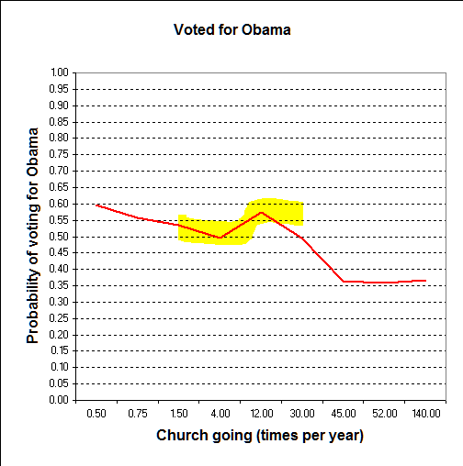

*Lets try a log

gen lnChGo = ln( chGoNowQ)
tab lnChGo, m
table chGoNowQ, c(m lnChGo sd lnChGo freq)
----------------------------------------------------
Church |
going |
(times |
per year) | mean(lnChGo) sd(lnChGo) Freq.
----------+-----------------------------------------
.5 | -.6931472 0 638
.75 | -.2876821 0 343
1.5 | .4054651 0 105
4 | 1.386294 0 300
12 | 2.484907 0 91
30 | 3.401197 0 98
45 | 3.806663 0 121
52 | 3.951244 0 364
140 | 4.941642 0 31
----------------------------------------------------

*compare
regress Obama married chGoNowQ fundmQ maleM ageM edNowQ rural status , beta
regress Obama married lnChGo fundmQ maleM ageM edNowQ rural status , beta

Source | SS df MS Number of obs = 1761
-------------+------------------------------ F( 8, 1752) = 13.13
Model | 24.894303 8 3.11178787 Prob > F = 0.0000
Residual | 415.201097 1752 .236986928 R-squared = 0.0566
-------------+------------------------------ Adj R-squared = 0.0523
Total | 440.0954 1760 .250054205 Root MSE = .48681

------------------------------------------------------------------------------
Obama | Coef. Std. Err. t P>|t| Beta
-------------+----------------------------------------------------------------
married | -.0392952 .0240634 -1.63 0.103 -.0392348
chGoNowQ | -.0027358 .0004775 -5.73 0.000 -.1396264
fundmQ | -.108006 .0264308 -4.09 0.000 -.0985007
maleM | -.058478 .0233353 -2.51 0.012 -.0583409
ageM | -.0014977 .0007727 -1.94 0.053 -.0468042
edNowQ | .005228 .0060891 0.86 0.391 .023857
rural | -.0930365 .0243788 -3.82 0.000 -.0895144
status | -.0005337 .0005748 -0.93 0.353 -.0255669
_cons | .6918279 .0837391 8.26 0.000 .
------------------------------------------------------------------------------

.
ln version just a tiny shade better.
Also it slightly reduces the fundamentalist effect.
. regress Obama married lnChGo fundmQ maleM ageM edNowQ rural status , beta
Source | SS df MS Number of obs = 1761
-------------+------------------------------ F( 8, 1752) = 13.42
Model | 25.4191591 8 3.17739488 Prob > F = 0.0000
Residual | 414.676241 1752 .236687352 R-squared = 0.0578
-------------+------------------------------ Adj R-squared = 0.0535
Total | 440.0954 1760 .250054205 Root MSE = .48651

------------------------------------------------------------------------------
Obama | Coef. Std. Err. t P>|t| Beta
-------------+----------------------------------------------------------------
married | -.0335144 .0241244 -1.39 0.165 -.0334629
lnChGo | -.0385657 .0065108 -5.92 0.000 -.1480154
fundmQ | -.094198 .0269749 -3.49 0.000 -.0859079
maleM | -.0630865 .0233263 -2.70 0.007 -.0629385
ageM | -.0014095 .0007736 -1.82 0.069 -.0440465
edNowQ | .0049805 .006079 0.82 0.413 .0227277
rural | -.0942817 .0243622 -3.87 0.000 -.0907125
status | -.0005477 .0005743 -0.95 0.340 -.0262372
_cons | .68954 .0836963 8.24 0.000 .
------------------------------------------------------------------------------

predict olsHat

*Now the probit version

probit Obama married lnChGo fundmQ maleM ageM edNowQ rural status
Probit regression Number of obs = 1761
LR chi2(8) = 103.79
Prob > chi2 = 0.0000
Log likelihood = -1168.4303 Pseudo R2 = 0.0425

------------------------------------------------------------------------------
Obama | Coef. Std. Err. z P>|z| [95% Conf. Interval]
-------------+----------------------------------------------------------------
married | -.0876795 .0631056 -1.39 0.165 -.2113643 .0360053
lnChGo | -.0994758 .0170512 -5.83 0.000 -.1328956 -.0660561
fundmQ | -.2439378 .0705319 -3.46 0.001 -.3821778 -.1056978
maleM | -.1634613 .0611786 -2.67 0.008 -.2833692 -.0435533
ageM | -.0037083 .0020261 -1.83 0.067 -.0076794 .0002628
edNowQ | .0130634 .0159141 0.82 0.412 -.0181276 .0442545
rural | -.2448727 .0637538 -3.84 0.000 -.3698279 -.1199175
status | -.00143 .0015035 -0.95 0.342 -.0043768 .0015167
_cons | .4915773 .2190722 2.24 0.025 .0622037 .9209509
------------------------------------------------------------------------------

. eval4 probit fundmQ "0 1"

*---------------------------------------------------------------------------------*
WHOLE POPULATION STANDARDIZATION. Version Jan 2009. For help: eval4 help
fundmQ Predicted s.e. ci Low ci High Now-prev Now-begin Now/begin
0 .5371 .03362 .4708 .6026 0 0 1
1 .4433 .03759 .3706 .518 -.09377 -.09377 .8254
*---------------------------------------------------------------------------------*
-- compare with OLS.
this is a 1st difference

eval4 probit maleM "0 1"

*---------------------------------------------------------------------------------*
WHOLE POPULATION STANDARDIZATION. Version Jan 2009. For help: eval4 help
maleM Predicted s.e. ci Low ci High Now-prev Now-begin Now/begin
0 .5415 .03422 .474 .6082 0 0 1
1 .4793 .03398 .4132 .5464 -.06224 -.06224 .8851
*---------------------------------------------------------------------------------*

eval4 probit lnChGo " ln(0.5) ln(52)"
*---------------------------------------------------------------------------------*
WHOLE POPULATION STANDARDIZATION. Version Jan 2009. For help: eval4 help
lnChGo Predicted s.e. ci Low ci High Now-prev Now-begin Now/begin
-.6931 .5828 .03489 .5133 .6501 0 0 1
3.951 .4038 .03697 .3331 .478 -.179 -.179 .6929
*---------------------------------------------------------------------------------*
this is a 1st difference

*Or we can graph the whole range
eval4 probit lnChGo " ln(0.5) ln(2.5) ln(12) ln(30) ln(52) ln(140)"
WHOLE POPULATION STANDARDIZATION. Version Jan 2009. For help: eval4 help
lnChGo Predicted s.e. ci Low ci High Now-prev Now-begin Now/begin
-.6931 .5828 .03489 .5133 .6501 0 0 1
.9163 .5209 .03337 .4553 .5861 -.06196 -.06196 .8937
2.485 .46 .0343 .3934 .5278 -.0609 -.1229 .7892
3.401 .4247 .03582 .3558 .4962 -.03523 -.1581 .7288
3.951 .4038 .03697 .3331 .478 -.02089 -.179 .6929
4.942 .3669 .0393 .2926 .4467 -.03689 -.2159 .6296
*---------------------------------------------------------------------------------*

*and OLS for comparison
regress Obama married lnChGo fundmQ maleM ageM edNowQ rural status, beta
eval4 linear lnChGo " ln(0.5) ln(2.5) ln(12) ln(30) ln(52) ln(140)"
WHOLE POPULATION STANDARDIZATION. Version Jan 2009. For help: eval4 help
lnChGo Predicted s.e. ci Low ci High Now-prev Now-begin Now/begin
-.6931 .5828 .03494 .5143 .6512 0 0 1
.9163 .5207 .03281 .4564 .585 -.06207 -.06207 .8935
2.485 .4602 .03389 .3938 .5266 -.06049 -.1226 .7897
3.401 .4249 .03586 .3546 .4951 -.03534 -.1579 .729
3.951 .4036 .03744 .3302 .477 -.02121 -.1791 .6926
4.942 .3654 .04093 .2852 .4457 -.0382 -.2173 .6271

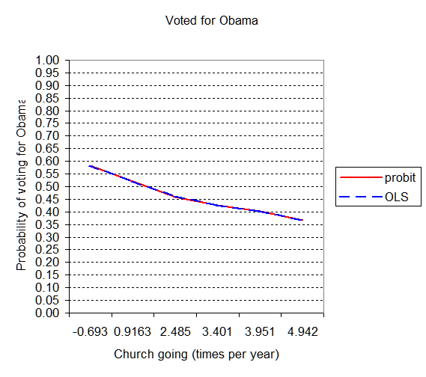

*Now a logit

logit Obama married lnChGo fundmQ maleM ageM edNowQ rural status
eval4 logit lnChGo " ln(0.5) ln(2.5) ln(12) ln(30) ln(52) ln(140)"
Logistic regression Number of obs = 1761
LR chi2(8) = 104.00
Prob > chi2 = 0.0000
Log likelihood = -1168.3221 Pseudo R2 = 0.0426

------------------------------------------------------------------------------
Obama | Coef. Std. Err. z P>|z| [95% Conf. Interval]
-------------+----------------------------------------------------------------
married | -.1418587 .1017754 -1.39 0.163 -.3413348 .0576175
lnChGo | -.1603161 .0275064 -5.83 0.000 -.2142276 -.1064046
fundmQ | -.3951919 .1138619 -3.47 0.001 -.6183571 -.1720266
maleM | -.2674947 .0989968 -2.70 0.007 -.4615248 -.0734646
ageM | -.0059722 .0032728 -1.82 0.068 -.0123868 .0004424
edNowQ | .0210661 .025743 0.82 0.413 -.0293892 .0715215
rural | -.397007 .1031344 -3.85 0.000 -.5991467 -.1948673
status | -.0023311 .0024365 -0.96 0.339 -.0071066 .0024444
_cons | .7956253 .3549391 2.24 0.025 .0999574 1.491293
------------------------------------------------------------------------------

*---------------------------------------------------------------------------------*
WHOLE POPULATION STANDARDIZATION. Version Jan 2009. For help: eval4 help
lnChGo Predicted s.e. ci Low ci High Now-prev Now-begin Now/begin
-.6931 .5827 .03488 .5129 .6497 0 0 1
.9163 .5206 .03353 .4547 .5862 -.06204 -.06204 .8935
2.485 .4595 .03443 .3929 .5278 -.06111 -.1232 .7886
3.401 .4242 .03585 .3556 .4961 -.03527 -.1584 .7281
3.951 .4034 .0369 .3332 .4778 -.02084 -.1793 .6923
4.942 .3668 .03897 .2937 .4464 -.03665 -.2159 .6294
*---------------------------------------------------------------------------------*

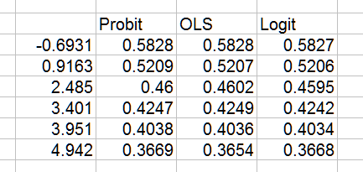

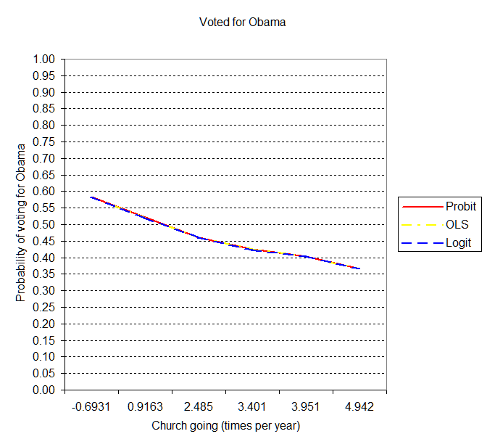

*"logistic" version rather than "logit"

logit Obama married lnChGo fundmQ maleM ageM edNowQ rural status
logistic Obama married lnChGo fundmQ maleM ageM edNowQ rural status
Logistic regression Number of obs = 1761
LR chi2(8) = 104.00
Prob > chi2 = 0.0000
Log likelihood = -1168.3221 Pseudo R2 = 0.0426

------------------------------------------------------------------------------
Obama | Coef. Std. Err. z P>|z| [95% Conf. Interval]
-------------+----------------------------------------------------------------
married | -.1418587 .1017754 -1.39 0.163 -.3413348 .0576175
lnChGo | -.1603161 .0275064 -5.83 0.000 -.2142276 -.1064046
fundmQ | -.3951919 .1138619 -3.47 0.001 -.6183571 -.1720266
maleM | -.2674947 .0989968 -2.70 0.007 -.4615248 -.0734646
ageM | -.0059722 .0032728 -1.82 0.068 -.0123868 .0004424
edNowQ | .0210661 .025743 0.82 0.413 -.0293892 .0715215
rural | -.397007 .1031344 -3.85 0.000 -.5991467 -.1948673
status | -.0023311 .0024365 -0.96 0.339 -.0071066 .0024444
_cons | .7956253 .3549391 2.24 0.025 .0999574 1.491293
------------------------------------------------------------------------------

.
. logistic Obama married lnChGo fundmQ maleM ageM edNowQ rural status

Logistic regression Number of obs = 1761
LR chi2(8) = 104.00
Prob > chi2 = 0.0000
Log likelihood = -1168.3221 Pseudo R2 = 0.0426

------------------------------------------------------------------------------
Obama | Odds Ratio Std. Err. z P>|z| [95% Conf. Interval]
-------------+----------------------------------------------------------------
married | .8677439 .088315 -1.39 0.163 .7108209 1.05931
lnChGo | .8518745 .023432 -5.83 0.000 .8071647 .8990608
fundmQ | .6735508 .0766918 -3.47 0.001 .538829 .8419567
maleM | .7652944 .0757617 -2.70 0.007 .6303218 .9291691
ageM | .9940456 .0032533 -1.82 0.068 .9876896 1.000442
edNowQ | 1.02129 .0262911 0.82 0.413 .9710384 1.074141
rural | .6723293 .0693403 -3.85 0.000 .5492801 .8229438
status | .9976716 .0024309 -0.96 0.339 .9929186 1.002447
_cons | 2.215826 .7864833 2.24 0.025 1.105124 4.442837
------------------------------------------------------------------------------

To get the odds ratios, start with the predicted values:
fundmQ Predicted s.e. ci Low ci High Now-prev Now-begin Now/begin
0 .5369 .03365 .4706 .6025 0 0 1
1 .4427 .03758 .3703 .5176 -.09425 -.09425 .8245
*---------------------------------------------------------------------------------*

*Now divide each predicted value by its compliment. this is the "odds"
. display .5369/(1 - .5369)
1.1593608

. display .4427/ (1 - .4427)
.79436569

. *odds ratio is the ratio of one to the other
. display .79436 / 1.1593
.68520659

